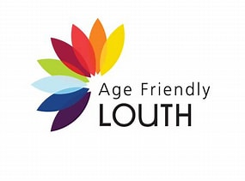
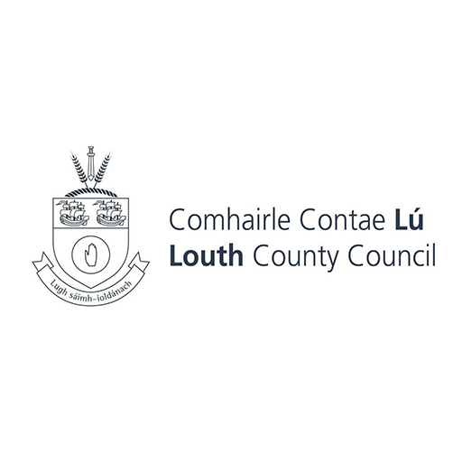
Louth Supports and Services Index for older people.

Please complete this form if you wish for your organisation/service to be included in the Louth supports and services index for older people. This will be a brief list of services/supports available to people over the age of 55 in Louth.
This index is only intended to be a brief overview on the supports and services available to older people in County Louth with relevant contact information to assist older people in finding a service they might need, when they need it.
It will be broken down into the headings of-
Home supports, Transport, Safety and Security, Health, Money Matters and Social Inclusion.

When completing this form, please outline which theme your service best fits into.

NAME OF ORGANISATIION/SERVICE:

ADDRESS:

EIRCODE:

CONTACT NAME:

ROLE:

CONTACT NUMBER:

CONTACT EMAIL:

WEBSITE:

BRIEF OUTLINE OF SERVICES PROVIDED (OPTIONAL) (100 WORDS MAX)

Which Municipal District area is your service available in?
DUNDALK/ NORTH LOUTH

DROGHEDA/ SOUTH LOUTH

ARDEE /MID LOUTH

WHOLE OF LOUTH

Which theme does your service for older people best fit into ?

TRANSPORT
HEALTH AND WELLBEING
SAFETY AND SECURITY
MONEY MATTERS
HOUSING/HOME SUPPORTS
SOCIAL INCLUSION

Does your service offer dedicated times for older people to access ?

YES NO N/A

IF yes, please outline

Is your premises fully accessible for wheelchairs ?

YES NO N/A

Do you have a dedicated older person’s helpline ?

YES NO N/A

If so please provide details:

The deadline for receipt of this completed form is –
5 pm March 31st 2026.
Please return to agefriendly@louthcoco.ie
If you have any questions, please let me know.

Kind regards,

Michael.

Michael Cotter
Clerical Officer ,
Social and community Office
Louth County Council.

