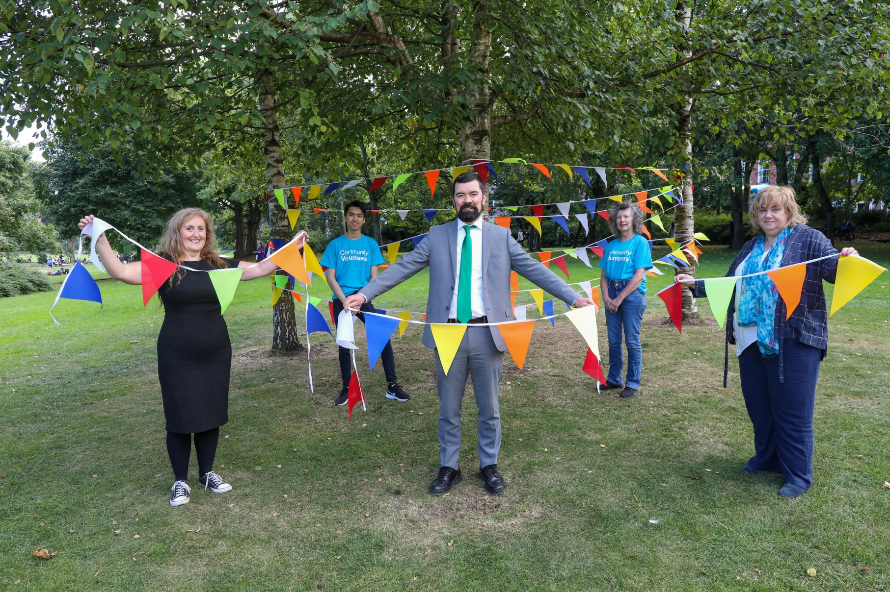
Pictured at the launch from left to right: Gráinne Berrill, Manager, Louth Volunteer Centre, Sai Kham Hloi, Community Volunteer, Minister Joe O’Brien, Patricia Hartley, Community Volunteer, Joan Martin, Chief Executive, Louth County Council.

