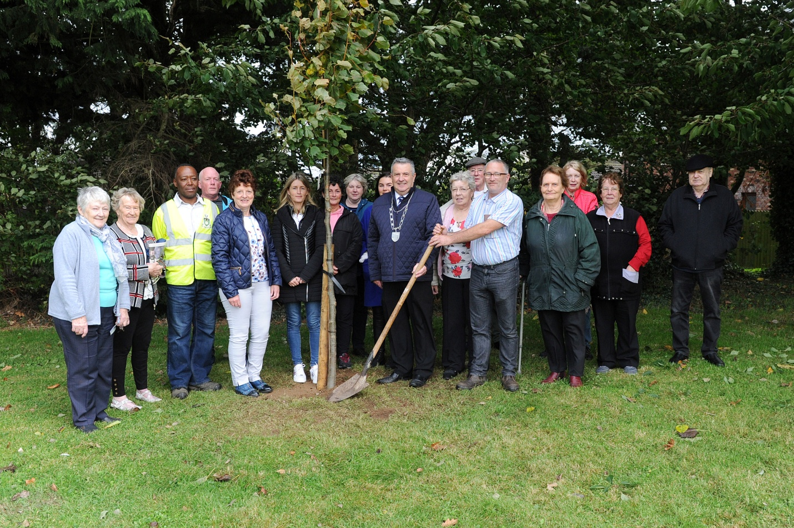
Tree planting at Sliabh Breagh, Ardee: Present are residents of Sliabh Breagh, Councillor Jim Tenanty Cathaoirleach of Ardee Municipal District, Catherine Duff Director of Services and Elias Mlimbila Louth County Council Parks Department. The residents requested that the tree be planted in memory of deceased residents of the Estate.

