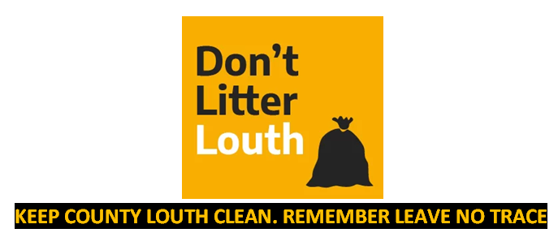
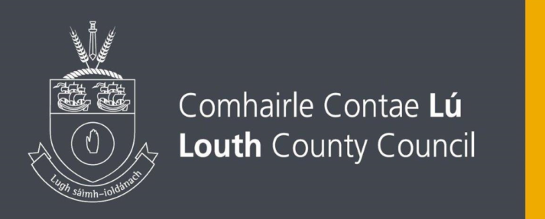

APPLICATION FOR PERMISSION TO ERECT POSTERS

Event being advertised: Date(s) Posters will be Erected: Locations:

Insurance Cover: Expiry Date:

Applicant’s Name: Address:

Contact No. Contact Email:

Date: Signed:
Please read the instructions thoroughly- see overleaf. Incomplete applications will be returned.

CONDITIONS FOR ERECTION OF POSTERS

Permission from Louth County Council for the erection of the posters is given subject to the following conditions being met:
- Submission of insurance indemnifying Louth County Council (public liability) for €6.5 million.
- Signs/Posters erected without permission will be subject to a litter fine.
- Permission of owners of other property to be obtained in advance.
- Posters to be erected 7 days prior to event.
- All signers/posters to be removed with 3 days of the last performance/event (cable ties to be removed also).
- Posters/Signs to be erected so as not to interfere with sight lines at junctions or the safe passage of pedestrians. They must not obscure motorists or pedestrian views of traffic lights, traffic management signs, directional signs or pose an obstruction.
- (a) Signs/Posters not to be erected on any council road signage or traffic light columns.
  - Signs/Posters should be affixed to metal poles, and not be affixed to wooden poles.
  - Signs/Posters not to be erected within 50 metres of any roundabout or any junction.
- Signs/Posters cannot be erected within the core area of any small town or village (i.e. within the 50 kph signs)
- Signs/Posters cannot be erected on any landscaped entrances to Towns/Villages.
- No Signs/Posters to be erected on/around Market Square, Dundalk or on or in the vicinity of the Ballymascanlon Roundabout.
- Fee payable €300, with a refund of €250 upon removal of all posters within 3 days of event. Cheques to be made payable to Louth County Council.

To ensure compliance please bring the above placement and removal conditions to the attention of those who will be erecting the posters.

Please complete this form and return to:

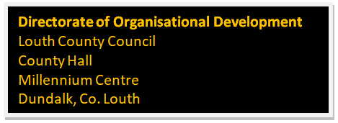
Tel: 1890 202 303
Email: environmentgroup@louthcoco.ie

