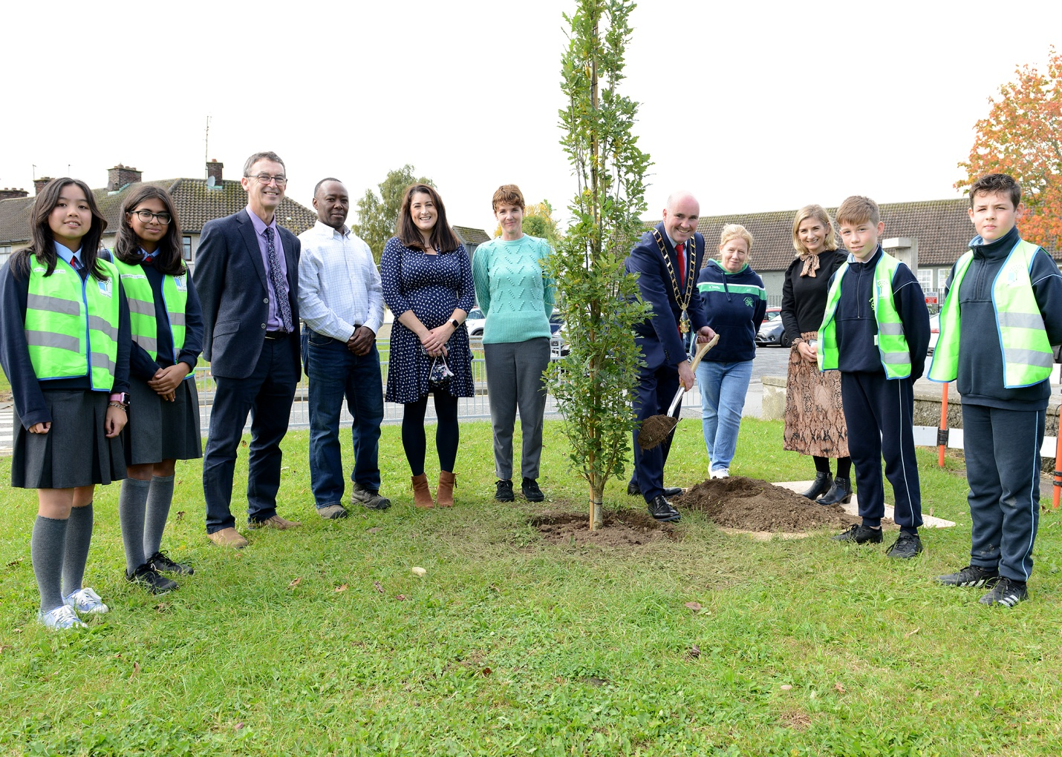
Students and Staff from St Patrick’s School joined Councillor James Byrne – Mayor of Drogheda, Willie Walsh Senior Executive Officer and Elias Mlimbila Parks Department, to plant a tree on the green area at Bóthar Brugha, Drogheda on National Tree Day.

