Report for the purposes of
Appropriate Assessment Screening

as required under Article 6(3) of the Habitats Directive
(Council Directive 92/43/EEC)

Ardee ETNS Extension

Prepared by: Moore Group – Environmental Services

2 December 2021



On behalf of
Louth County Council

Project Proponent | Louth County Council
Project | Ardee ETNS Extension
Title | Report for the purposes of Appropriate Assessment Screening  Ardee ETNS Extension

Project Number | 21314 | Document Ref | 21314 Ardee ETNS Extension AAS1 Rev3
Revision | Description | Author |  | Date
Rev3 | LCC Engineering Reviewed |   G. O’Donohoe |  | 2 December 2021
Moore Archaeological and Environmental Services Limited

Table of Contents
1. Introduction 1
1.1. General Introduction 1
1.2. Legislative Background - The Habitats and Birds Directives 2
2. Methodology 3
2.1. Guidance 3
2.2. Data Sources 4
3. Description of the Proposed Development 5
4. Identification of Natura 2000 Sites 9
4.1. Description of Natura Sites Potentially Affected 9
4.2. Ecological Network Supporting Natura 2000 Sites 13
5. Identification of Potential Impacts & Assessment of Significance 13
5.1. Assessment of Likely Significant Effects 13
5.2. Assessment of Potential In-Combination Effects 16
6. Conclusion 20
7. References 21

Appendix A – Finding of No Significant Effects Report
Abbreviations
AA Appropriate Assessment
EEC European Economic Community
EPA Environmental Protection Agency
EU European Union
GIS Geographical Information System
LAP Local Area Plan
NHA Natural Heritage Area
NIS Natura Impact Statement
NPWS National Parks and Wildlife Service
OSI Ordnance Survey Ireland
pNHA proposed Natural Heritage Area
SAC Special Area of Conservation
SPA Special Protection Area
SuDS Sustainable Drainage System
WFD Water Framework Directive

1. Introduction

1.1. General Introduction
This report for the purposes of Appropriate Assessment (AA) Screening has been prepared to support a Part 8 Application for the Proposed Development (described in Section 3 below). This report contains information required for the competent authority to undertake screening for Appropriate Assessment (AA) on the potential construction of an extension to the approved development of Ardee Educate Together National School, Co. Louth (hereafter referred to as the Proposed Development) to significantly affect European sites.
Screening is the process that addresses the first two tests of Article 6(3) of Council Directive 92/43/EEC on the Conservation of Natural Habitats and of Wild Fauna and Flora (as amended) (referred to as the Habitats Directive):
- whether a plan or project is directly connected to or necessary for the management of the site, and
- whether a plan or project, alone or in combination with other plans and projects, is likely to have significant effects on a Natura 2000 site in view of its conservation objectives.
Having regard to the provisions of the Planning and Development Act 2000 (section 177U and 177V), the purpose of a screening exercise under section 177U of the PDA 2000 is to assess, in view of best scientific knowledge, if the proposed development, individually or in combination with another plan or project is likely to have a significant effect on a European site.
If it cannot be excluded on the basis of objective information that the proposed development, individually or in combination with other plans or projects, will have a significant effect on a European site then it is necessary to carry out a Stage 2 appropriate assessment.
When screening the project, there are two possible outcomes:
- the project poses no risk of a significant effect and as such requires no further assessment; and
- the project has potential to have a significant effect (or this is uncertain) and AA of the project is necessary.
This report has been prepared by Moore Group - Environmental Services to support a Part 8 application for the Proposed Development to allow Louth County Council to carry out AA screening in relation to the Proposed Development. The report was compiled by Ger O’Donohoe (B.Sc. Applied Aquatic Sciences (GMIT, 1993) & M.Sc. Environmental Sciences (TCD, 1999)) who has 25 years’ experience in environmental impact assessment and has completed numerous Appropriate Assessment Screening Reports and Natura Impact Statements on terrestrial and aquatic habitats for various development types.

1.2. Legislative Background - The Habitats and Birds Directives
It is necessary that the Proposed Development has regard to Article 6 of the Habitats Directive. This is transposed into Irish Law by the European Communities (Birds and Natural Habitats) Regulations, 2011 to 2015 (referred to as the Habitats Regulations). The Planning and Development Act 2000 (section 177U and 177V) govern the requirement to carry out appropriate assessment per Section 1.1 above.
The Habitats Directive is the main legislative instrument for the protection and conservation of biodiversity in the European Union (EU). Under the Habitats Directive, Member States are obliged to designate Special Areas of Conservation (SACs) which contain habitats or species considered important for protection and conservation in a EU context.
The Birds Directive (Council Directive 2009/147/EC on the Conservation of Wild Birds), transposed into Irish law by the Habitats Regulations 2011, is concerned with the long-term protection and management of all wild bird species and their habitats in the EU. Among other things, the Birds Directive requires that Special Protection Areas (SPAs) be established to protect migratory species and species which are rare, vulnerable, in danger of extinction, or otherwise require special attention.
SACs designated under the Habitats Directive and SPAs, designated under the Birds Directive, form a pan-European network of protected sites known as Natura 2000. The Habitats Directive sets out a unified system for the protection and management of SACs and SPAs. These sites are also referred to as European sites.
Articles 6(3) and 6(4) of the Habitats Directive set out the requirement for an assessment of proposed plans and projects likely to affect Natura 2000 sites.
Article 6(3) establishes the requirement to screen all plans and projects and to carry out a further assessment if required (Appropriate Assessment (AA)). Article 6(4) establishes requirements in cases of imperative reasons of overriding public interest:
Article 6(3): “Any plan or project not directly connected with or necessary to the management of the site but likely to have a significant effect thereon, either individually or in combination with other plans or projects, shall be subjected to an appropriate assessment of its implications for the site in view of the site’s conservation objectives. In light of the conclusions of the assessment of the implications for the site and subject to the provisions of paragraph 4, the competent national authorities shall agree to the plan or project only after having ascertained that it will not adversely affect the integrity of the site concerned and, if appropriate, after having obtained the opinion of the general public.”

2. Methodology
The Commission’s methodological guidance (EC, 2002 & 2018, see Section 2.1 below) promotes a four-stage process to complete the AA and outlines the issues and tests at each stage. An important aspect of the process is that the outcome at each successive stage determines whether a further stage in the process is required.
Stages 1 and 2 deal with the main requirements for assessment under Article 6(3). Stage 3 may be part of Article 6(3) or may be a necessary precursor to Stage 4. Stage 4 is the main derogation step of Article 6(4).
Stage 1 Screening: This stage examines the likely effects of a project either alone or in combination with other projects upon a Natura 2000 site and considers whether it can be objectively concluded that these effects will not be significant. In order to screen out a project, it must be excluded, on the basis of objective information, that the Proposed Development, individually or in combination with other plans or projects, will have a significant effect on a European site.
Stage 2 Appropriate Assessment: In this stage, there is a consideration of the impact of the project with a view to ascertain whether there will be any adverse effect on the integrity of the Natura 2000 site either alone or in combination with other projects or plans, with respect to the site’s structure and function and its conservation objectives. Additionally, where there are predicted impacts, an assessment of the potential mitigation of those impacts is considered.
Stage 3 Assessment of Alternative Solutions: This stage examines alternative ways of implementing the project that, where possible, avoid any adverse impacts on the integrity of the Natura 2000 site.
Stage 4 Assessment where no alternative solutions exist and where adverse impacts remain: Where imperative reasons of overriding public interest (IROPI) exist, an assessment to consider whether compensatory measures will or will not effectively offset the damage to the sites will be necessary.
To ensure that the Proposed Development complies fully with the requirements of Article 6 of the Habitats Directive and all relevant Irish transposing legislation, Moore Group compiled this report to support an application for planning permission for the Proposed Development to allow Louth County Council to carry out AA screening in relation to the Proposed Development to determine whether the Proposed Development, individually or in combination with another plan or project will have a significant effect on a Natura 2000 site.

2.1. Guidance
This report has been compiled in accordance with guidance contained in the following documents:
- Appropriate Assessment of Plans and Projects in Ireland - Guidance for Planning Authorities. (Department of Environment, Heritage and Local Government, 2010 rev.).
- Appropriate Assessment under Article 6 of the Habitats Directive: Guidance for Planning Authorities. Circular NPWS 1/10 & PSSP 2/10.
- Managing Natura 2000 Sites: The Provisions of Article 6 of the Habitat’s Directive 92/43/EEC (EC Environment Directorate-General, 2000); hereafter referred to as MN2000.
- Managing Natura 2000 Sites: The Provisions of Article 6 of the Habitat’s Directive 92/43/EEC (EC, 2018).
- OPR Practice Note PN01 Appropriate Assessment Screening for Development Management (OPR, 2021).
- Guidance document on the strict protection of animal species of Community interest under the Habitats Directive (EC, 2021).
- Assessment of plans and projects in relation to Natura 2000 sites - Methodological guidance on Article 6(3) and (4) of the Habitats Directive 92/43/EEC (EC, 2021).

2.2. Data Sources
Sources of information that were used to collect data on the Natura 2000 network of sites, and the environment within which they are located, are listed below:
- The following mapping and Geographical Information Systems (GIS) data sources, as required:
  - National Parks & Wildlife (NPWS) protected site boundary data;
  - Ordnance Survey of Ireland (OSI) mapping and aerial photography;
  - OSI/Environmental Protection Agency (EPA) rivers and streams, and catchments;
  - Open Street Maps;
  - Digital Elevation Model over Europe (EU-DEM);
  - Google Earth and Bing aerial photography 1995-2021;
- Online data available on Natura 2000 sites as held by the National Parks and Wildlife Service (NPWS) from www.npws.ie including:
  - Natura 2000 - Standard Data Form;
  - Conservation Objectives;
  - Site Synopses;
- National Biodiversity Data Centre records;
  - Online database of rare, threatened and protected species;
  - Publicly accessible biodiversity datasets.
- Status of EU Protected Habitats in Ireland. (National Parks & Wildlife Service, 2019); and
- Relevant Development Plans;
  - Louth County Development Plan 2021-2027

3. Description of the Proposed Development
The Proposed Development consists of the development of Ardee Educate Together National School, N52/Jervis St., Ardee, Co. Louth (Figure 1). The new school building is to be located on improved agricultural grassland.
The project includes an additional 4 Class Extension to the previously approved scheme for an 8 Class Primary School. The scheme proposals have been amended to allow for an increase in Special Needs Accommodation to include a 4 Class SEN Suite in lieu of the previously approved 2 Class Suite in accordance with Department of Education requirements. The revised schedule of accommodation now includes 8 General Classrooms, 4 Special Needs Classrooms and all associated administrative and ancillary accommodation (Figure 2).
The project will be connected to the public wastewater treatment system which has the capacity to assimilate the wastewater.

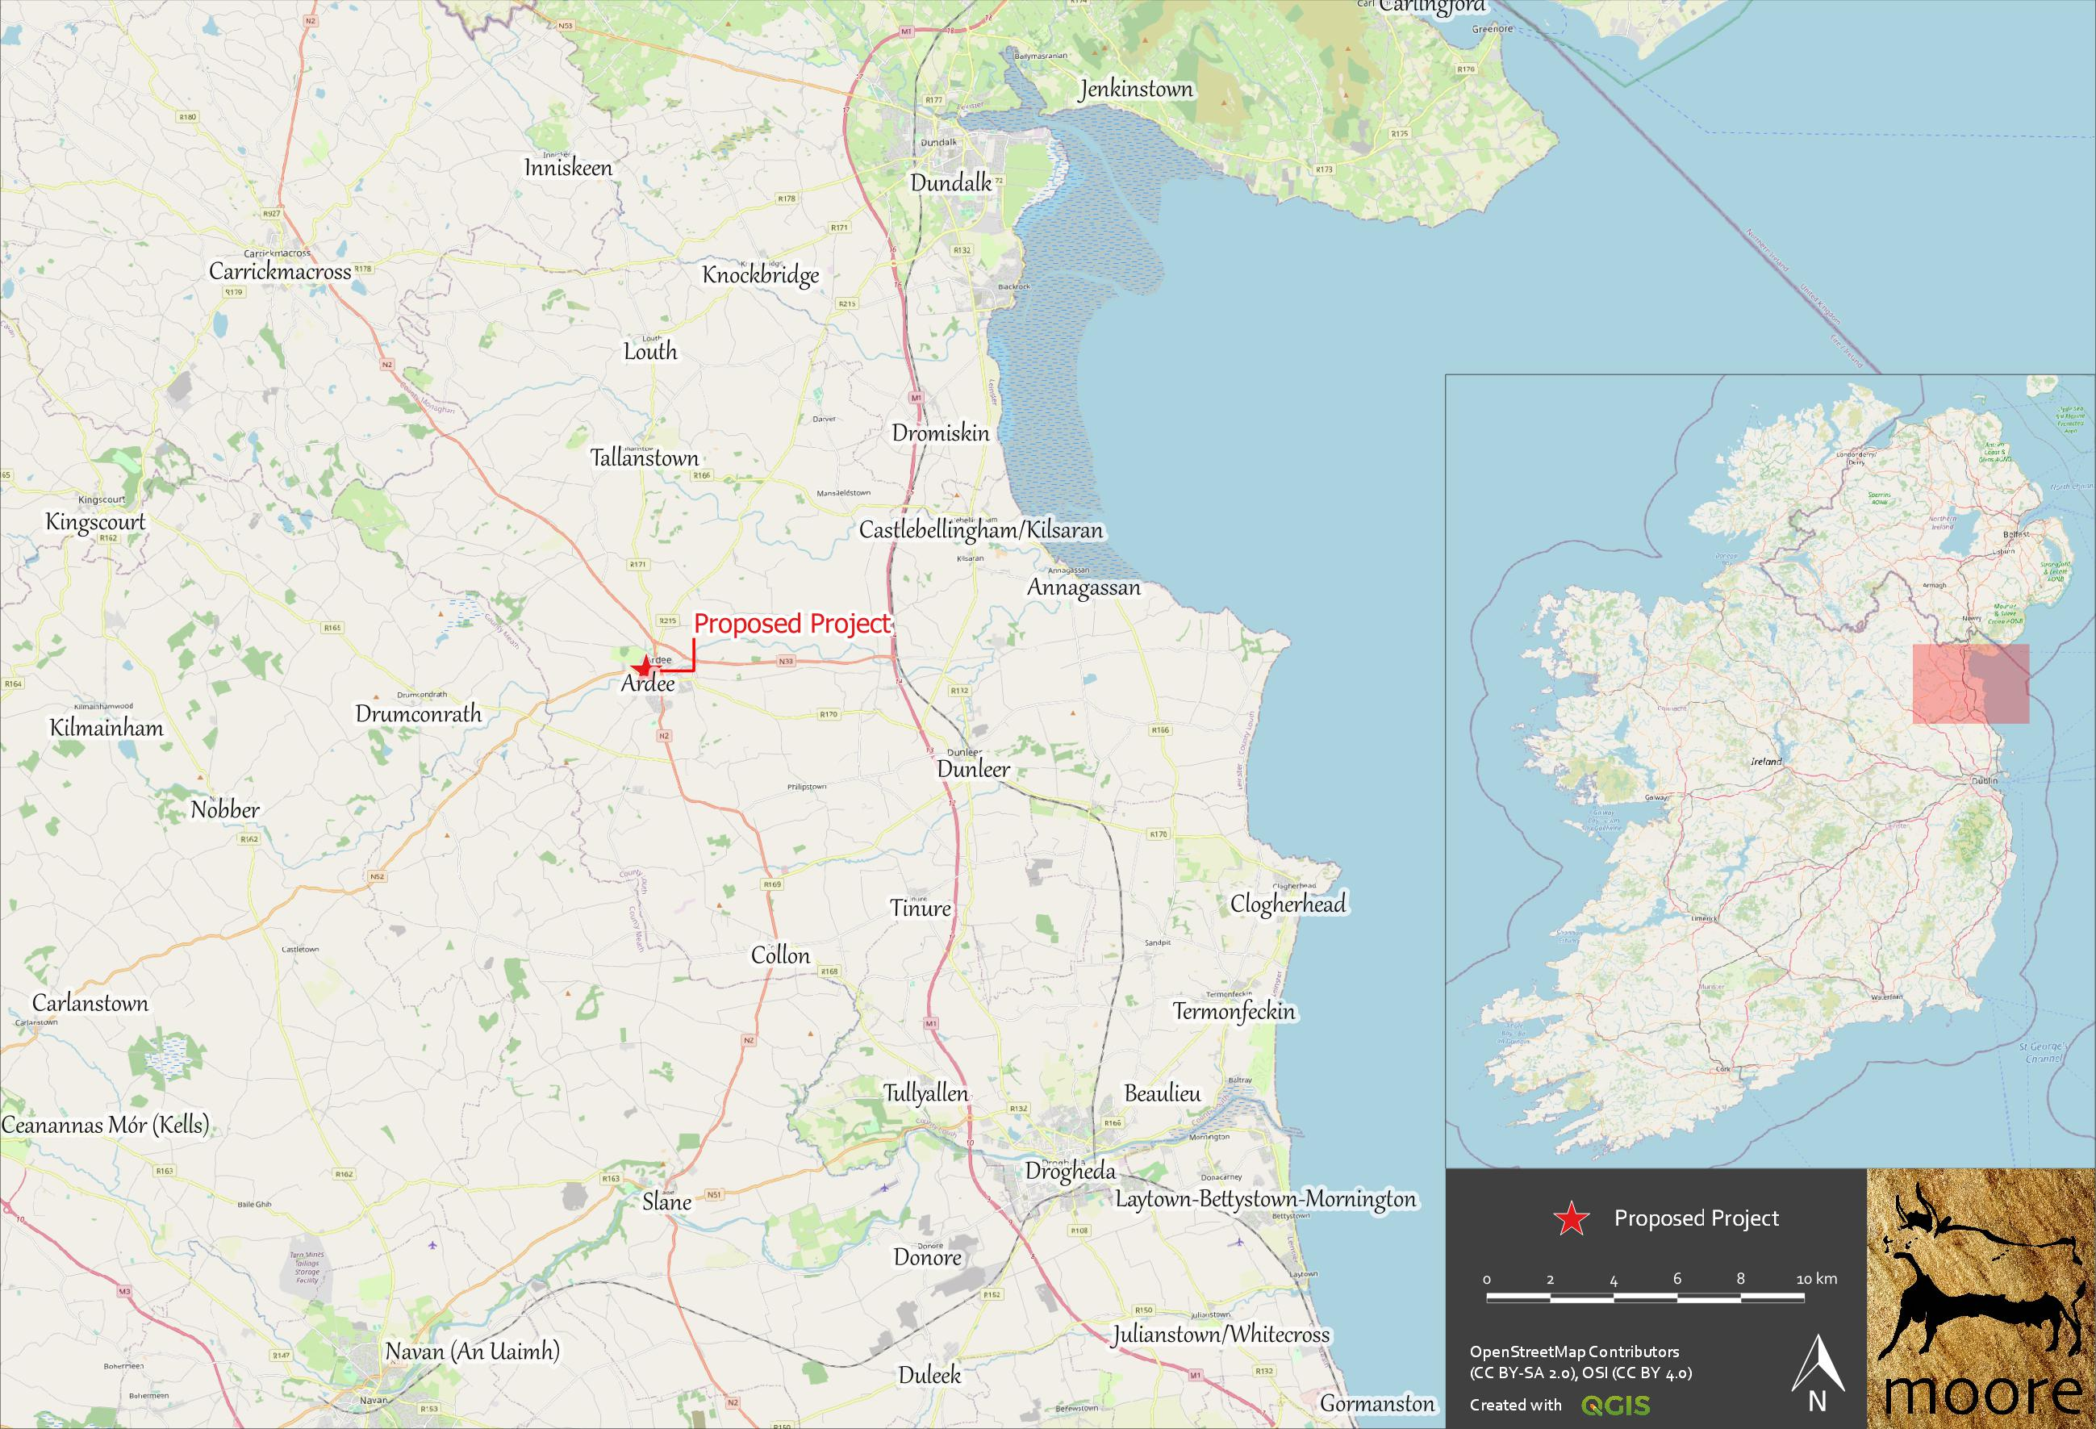
Figure 1. Showing the Proposed Development location at Ardee, Co. Louth.
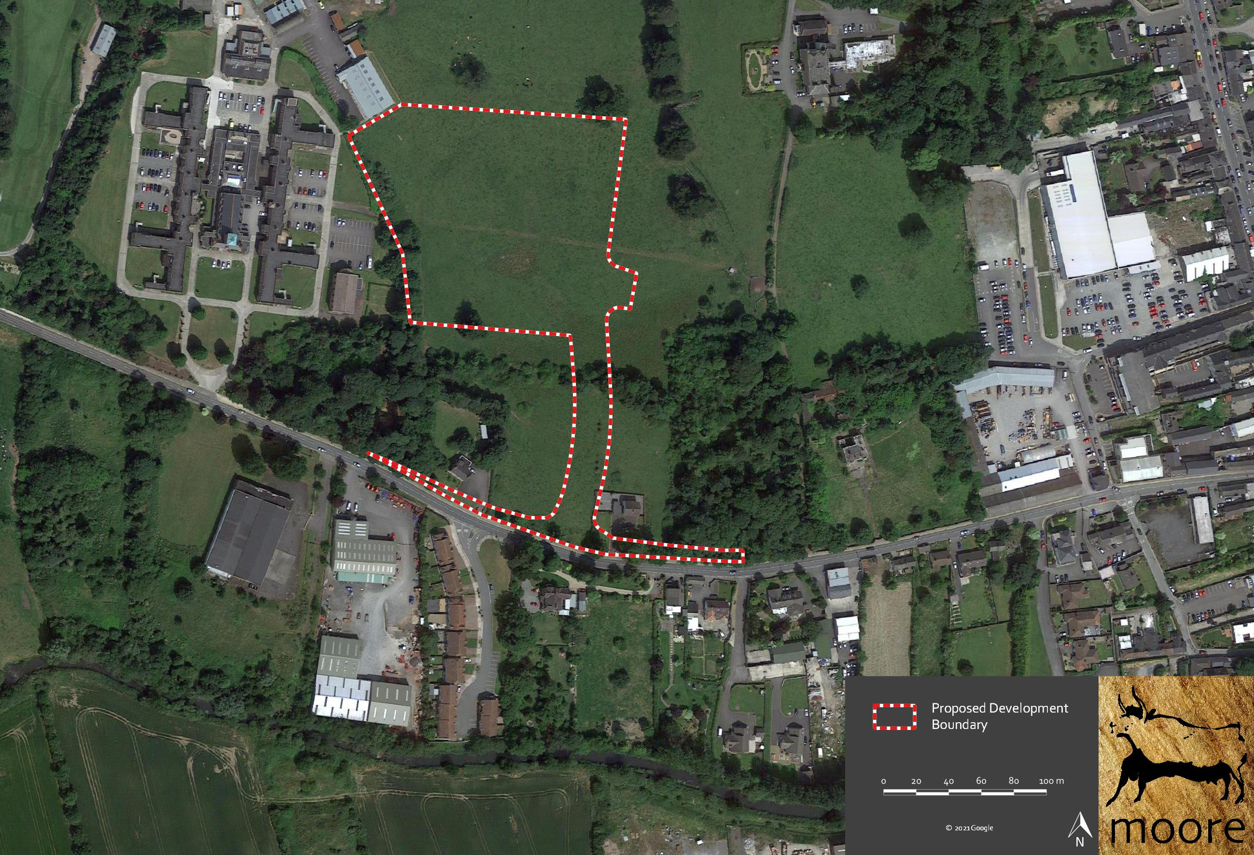
Figure 2. Showing the Proposed Development boundary on recent aerial photography.

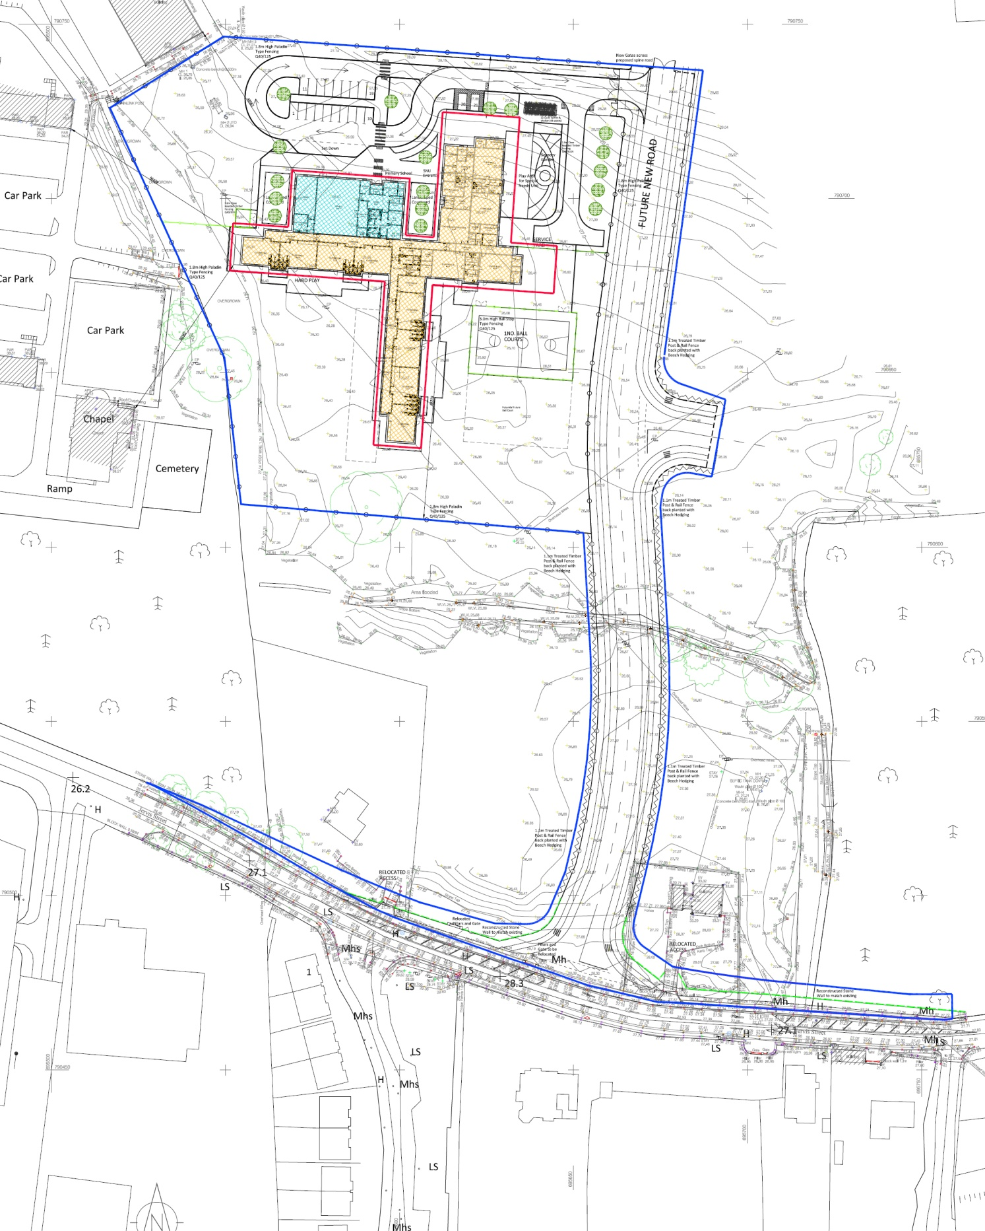
Figure 3. Detailed Plan of the Proposed Development showing the previously granted school in blue and proposed extension in yellow.

4. Identification of Natura 2000 Sites

4.1. Description of Natura Sites Potentially Affected
The Department of Housing, Planning and Local Government (previously DoEHLG)’s Guidance on Appropriate Assessment (2009) recommends an assessment of European sites within a Zone of Influence (ZoI) of 15km. This distance is a guidance only and a potential Zone of Influence of a proposed development is the geographical area over which it could affect the receiving environment in a way that could have significant effects on the Qualifying Interests of a European site. This should be established on a case-by-case basis using the Source- Pathway-Receptor framework and not by arbitrary distances (such as 15km).
The Zone of Influence may be determined by connectivity to the Proposed Development in terms of:
- Nature, scale, timing and duration of works and possible impacts, nature and size of excavations, storage of materials, flat/sloping sites;
- Distance and nature of pathways (dilution and dispersion; intervening ‘buffer’ lands, roads etc.); and
- Sensitivity and location of ecological features.
The potential for source pathway receptor connectivity is firstly identified and detailed information is then provided on sites with connectivity. European sites that are located within the potential Zone of Influence of the Proposed Development are listed in Table 1 and presented in Figure 4 below. Spatial boundary data on the Natura 2000 network was extracted from the NPWS website (www.npws.ie) on the 1 November 2021.
Table 1 European Sites located within the potential Zone of Influence of the Proposed Development.
Site Code | Site name | Distance (km)
000455 | Dundalk Bay SAC | 12.69
004026 | Dundalk Bay SPA | 12.68
004091 | Stabannan-Braganstown SPA | 5.55
The nearest European sites to the Proposed Development is the Stabannan-Braganstown SPA (Site Code 004091), which is located approximately 5.6km to the northeast. However, there is no connectivity to this site.
The Proposed Development is located within the hydrological catchment of the River Dee which flows from west to east over 120m to the south of the entrance to the site off the N52. The site is drained by a ditch which leads to the River Dee. Downstream, the waters of the River Dee enter Dundalk Bay with its European sites, the Boyne Coast and Estuary SAC (Site Code 001957) and the Boyne Estuary SPA (Site Code 004080), which are located over 20 river km downstream of the Proposed Development.
There is no connectivity to any other European sites within or outside the potential Zone of Influence.
The Qualifying Interests (QIs) and Special Conservation Interests (SCIs) of the European sites in the vicinity of the Proposed Development are provided in Table 2 below.

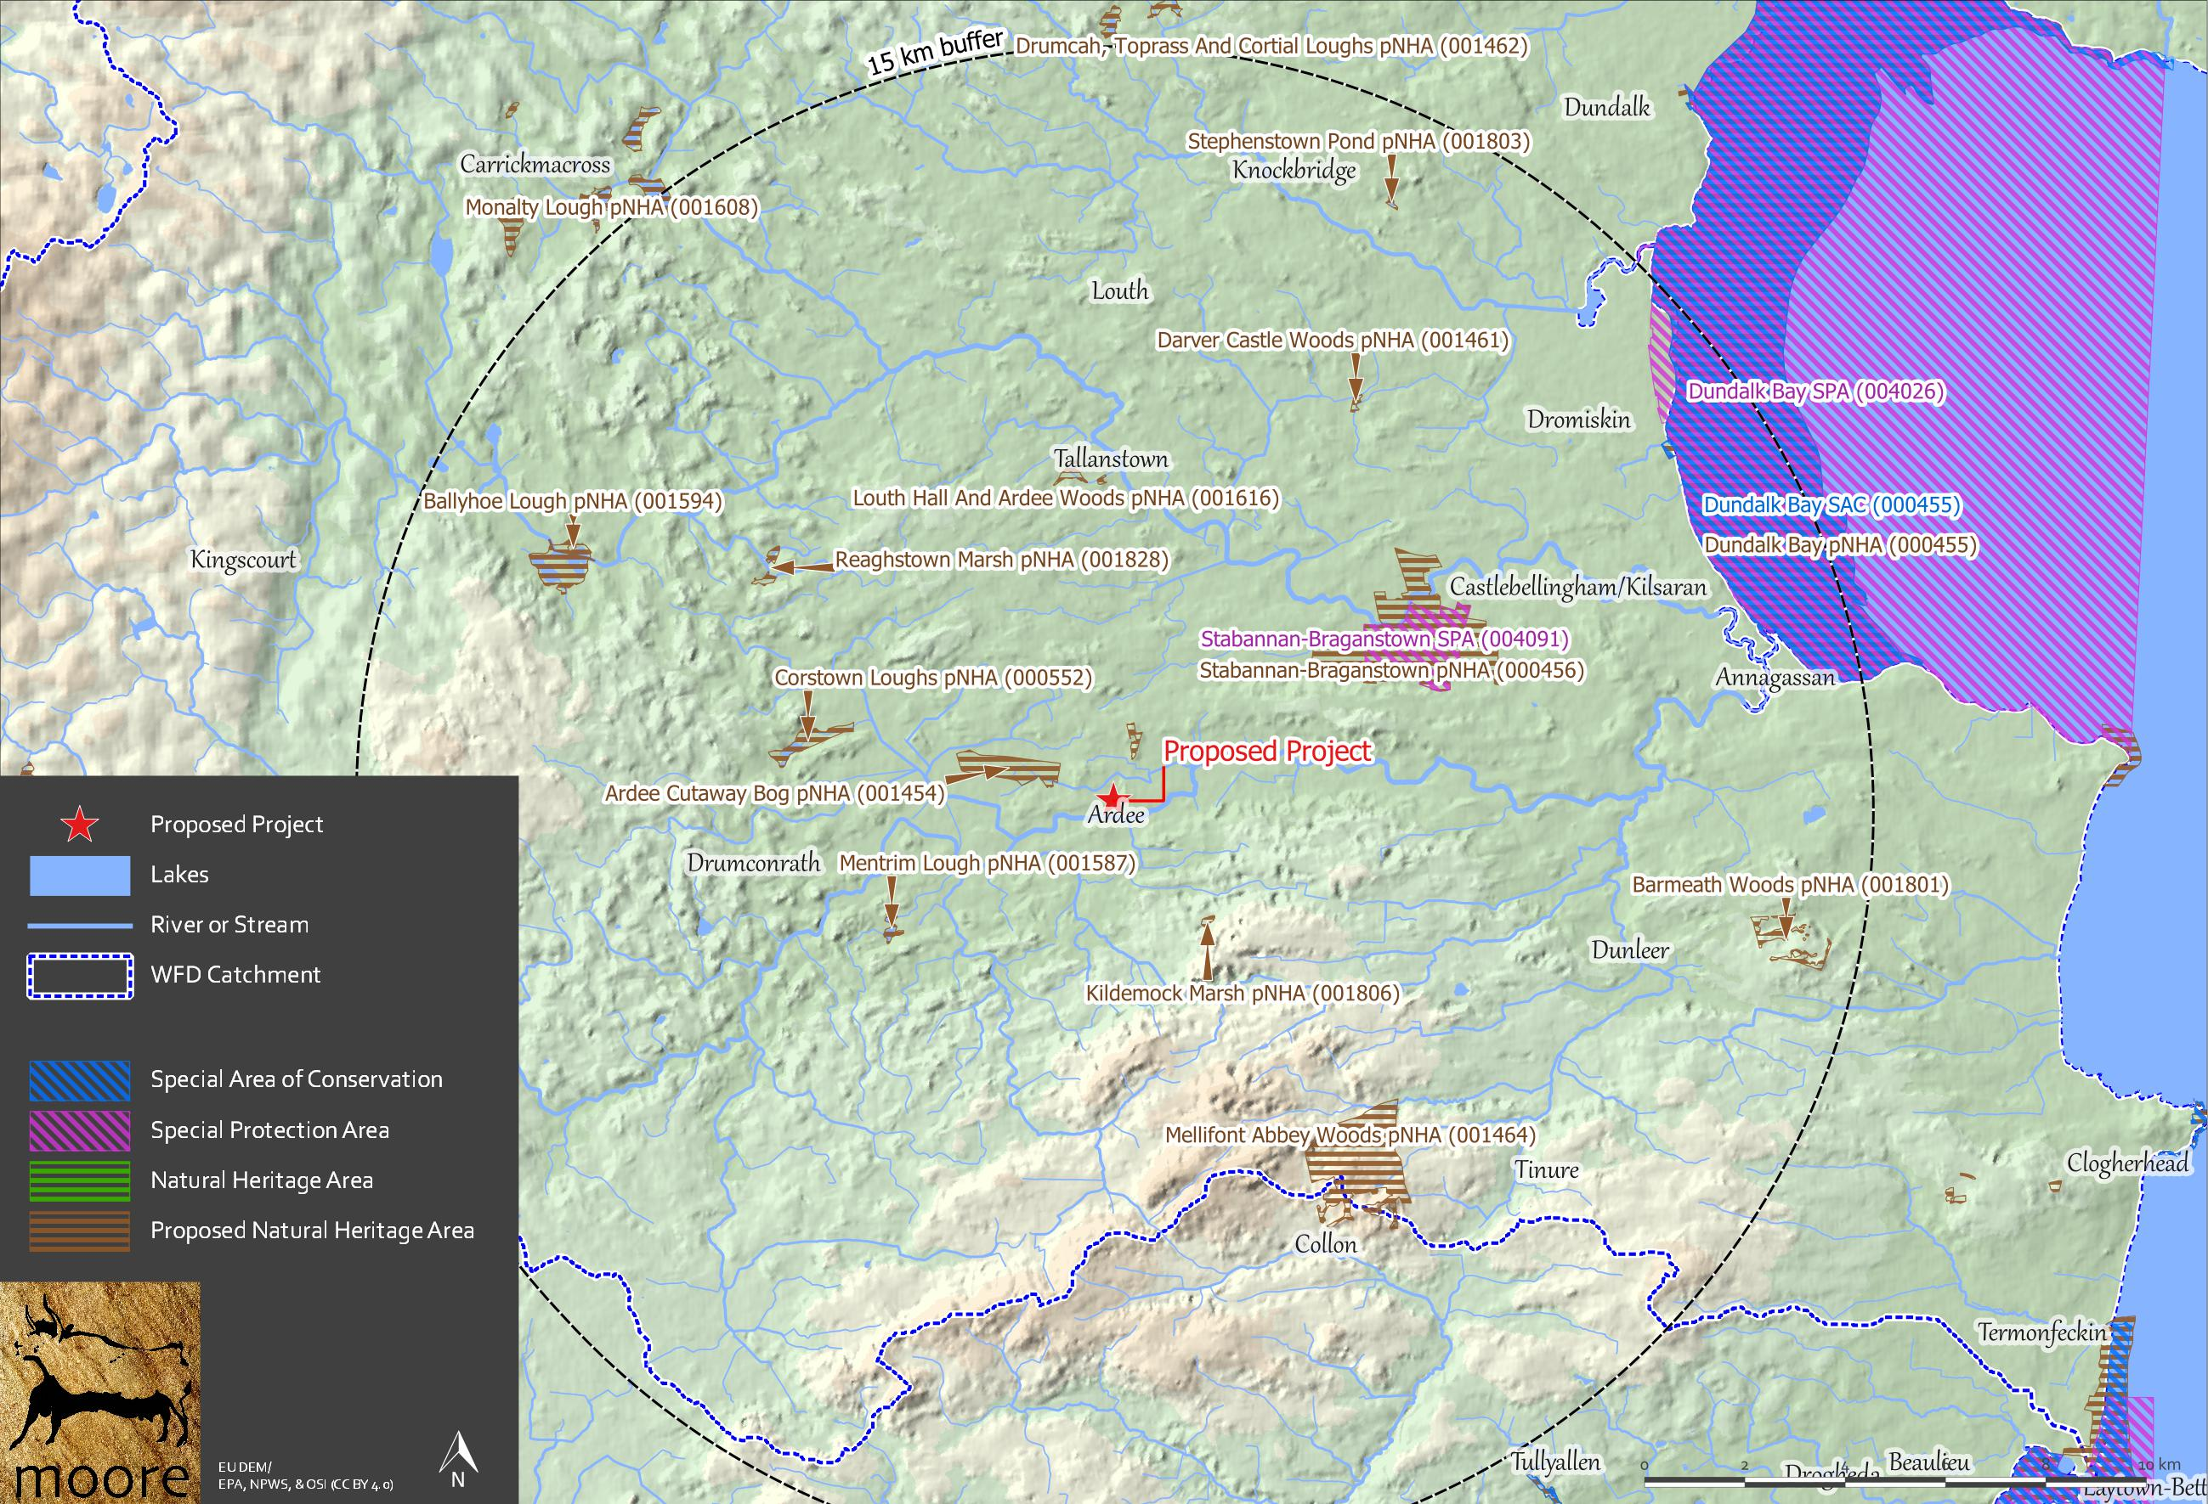
Figure 4. Showing European sites and NHAs/pNHAs within the wider Potential Zone of Influence of the Proposed Development.

Table 2 Identification of relevant European sites using Source-Pathway-Receptor model and compilation of information QIs and conservation objectives.
European site name & Site code | Location Relative to the Proposed Development Site | Connectivity – Source-Pathway-Receptor | Considered further in Screening – Y/N
Dundalk Bay SAC (001957)  1130 Estuaries  1140 Mudflats and sandflats not covered by seawater at low tide  1220 Perennial vegetation of stony banks  1310 Salicornia and other annuals colonizing mud and sand  1330 Atlantic salt meadows (Glauco‐Puccinellietalia maritimae)  1410 Mediterranean salt meadows (Juncetalia maritimi)  NPWS (2011) Conservation Objectives: Dundalk Bay SAC 000455 and Dundalk Bay SPA 004026. Version 1.0.National Parks and Wildlife Service, Department of Arts, Heritage and the Gaeltacht. | 12.7km to the north-east of the Proposed Development and over 20 river km downstream on the River Dee. | There is very distant connectivity via the River Dee located over 20 river km downstream. | Y
Dundalk Bay SPA (004080)  24 SCI’s including 23 species of shorebirds and A999 Wetlands & Waterbirds  NPWS (2011) Conservation Objectives: Dundalk Bay SAC 000455 and Dundalk Bay SPA 004026. Version 1.0. National Parks and Wildlife Service, Department of Arts, Heritage and the Gaeltacht. | 12.7km to the northeast of the Proposed Development and over 20 river km downstream on the River Dee. | The site does not have suitable supporting habitats for the SPA species of either the Stabannan-Braganstown SPA or the Dundalk Bay SPA.  There is very distant connectivity via the River Dee located over 20 river km downstream. | Y
Stabannan-Braganstown SPA (004158)  [A043] Greylag Goose (Anser anser)  NPWS (2021) Conservation objectives for Stabannan-Braganstown SPA [004091]. Generic Version 8.0. Department of Housing, Local Government and Heritage | 5.6km to the northeast of the Proposed Development | There is no connectivity to the habitats of this site.  No  Due to distance and the lack of any relevant ex-situ factors of significance to these species or habitat. | N

4.2. Ecological Network Supporting Natura 2000 Sites
An analysis of the proposed Natural Heritage Areas (pNHA) and designated Natural Heritage Areas (NHA) in terms of their role in supporting the species using Natura 2000 sites was undertaken. It was assumed that these supporting roles mainly related to mobile fauna such as mammals and birds which may use pNHAs and NHAs as “stepping stones” between Natura 2000 sites.
Article 10 of the Habitats Directive and the Habitats Regulations 2011 place a high degree of importance on such non-Natura 2000 areas as features that connect the Natura 2000 network. Features such as ponds, woodlands and important hedgerows were taken into account during the preparation of this AA Screening report .
There are no other areas of conservation concern that would be affected by the Proposed Development.
The NHAs and pNHAs identified in Figure 4 are located outside the Zone of Influence. There are no areas of supporting habitat that will be affected by the Proposed Development.

5. Identification of Potential Impacts & Assessment of Significance
The Proposed Development is not directly connected with or necessary to the management of the sites considered in the assessment and therefore potential impacts must be identified and considered.

5.1. Assessment of Likely Significant Effects
There is very distant connectivity via the River Dee to Dundalk Bay SAC & SPA located over 20 river km downstream. There is no connectivity to any other European sites within or outside the potential Zone of Influence.
The consideration of all potential direct and indirect impacts that may result in significant effects on the conservation objectives of a European site, taking into account the size and scale of the Proposed Development are presented in Table 3.

Table 3 Assessment of Likely Significant Effects.
Identification of all potential direct and indirect impacts that may result in significant effects on the conservation objectives of a European site, taking into account the size and scale of the project.
Impacts: | Significance of Impacts:
Construction phase e.g.  Vegetation clearance  Demolition  Surface water runoff from soil excavation/infill/landscaping (including borrow pits)  Dust, noise, vibration  Lighting disturbance  Impact on groundwater/dewatering  Storage of excavated/construction materials  Access to site  Pests | There is very distant connectivity via the River Dee at over 20 river km downstream to Dundalk Bay.  The potential sources of pollution from the construction of the proposed development are from cementitious water or chemical spill from fuels. The potential effects from elevated suspended solids would be negligible in a coastal system which experiences existing high levels of sediment flux in the Irish Sea.  The possibility of a pollution event reaching the habitats of Dundalk Bay is highly unlikely due to the distance of removal where either, suspended solids would settle, cementitious water would neutralise and hydrocarbons would be dispersed in the first 500m to 1km of freshwater dilution.
Operational phase e.g.  Direct emission to air and water  Surface water runoff containing  contaminant or sediment  Lighting disturbance  Noise/vibration  Changes to water/groundwater due to drainage or abstraction  Presence of people, vehicles and activities  Physical presence of structures (e.g. collision risks)  Potential for accidents or incidents | All foul and surface water runoff, once the facility is operational, will be contained on site and discharged to urban drainage systems.  There is no real likelihood of any significant effects on European Sites in the wider catchment area.  The facility is located at a distance of removal such that there will be no disturbance to qualifying interest species in any European sites.
In-combination/Other | No likely significant in-combination effects are identified.
Describe any likely changes to the European site:
Examples of the type of changes to give consideration to include:  Reduction or fragmentation of habitat area  Disturbance to QI species  Habitat or species fragmentation  Reduction or fragmentation in species density  Changes in key indicators of conservation status value (water quality etc.)  Changes to areas of sensitivity or threats to QI  Interference with the key relationships that define the structure or ecological function of the site  Climate change | None.  The Proposed Development site is not located adjacent or within a European site, therefore there is no risk of habitat loss or fragmentation or any effects on QI habitats or species directly or ex-situ.
Are ‘mitigation’ measures necessary to reach a conclusion that likely significant effects can be ruled out at screening?
No | While best practice construction methods may be included these are not required to avoid or reduce any effects on a European site. These measures are not relied upon to reach a conclusion of no likely significant effects on any European site.
On the basis of the information supplied, which is considered adequate to undertake a screening determination and having regard to:
- the nature and scale of the proposed development,
- the intervening land uses and distance from European sites,
- the lack of direct connections with regard to the Source-Pathway-Receptor model,
It may be concluded that the proposed development, individually or in-combination with other plans or projects, would not be likely to have a significant effect on the above listed European sites or any other European site, in view of the said sites’ conservation objectives.

5.2. Assessment of Potential In-Combination Effects
In-combination effects are changes in the environment that result from numerous human-induced, small-scale alterations. In-combination effects can be thought of as occurring through two main pathways: first, through persistent additions or losses of the same materials or resource, and second, through the compounding effects as a result of the coming together of two or more effects.
As part of the Screening for an Appropriate Assessment, in addition to the Proposed Development, other relevant plans and projects in the area must also be considered at this stage. This step aims to identify at this early stage any possible significant in-combination effects of the Proposed Development with other such plans and projects on European sites.
A review of the National Planning Application Database was undertaken. The first stage of this review confirmed that there were no data outages in the area where the Proposed Development is located. The database was then queried for developments granted planning permission within 100m of the Proposed Development within the last three years, these are presented in Table 4 below.
Table 4.Planning applications granted permission in the vicinity of the Proposed Development.
Planning Ref. | Description of development | Comments
N/A | An initial Assessment Report was completed in March 2015 in advance of the previous Planning Application that included an 8 class Primary School and 2 Class SEN Suite. This Assessment includes for the provision of an 8 class Primary School and 4 Class SEN Suite. 4 general classrooms in the previous approval are to redesigned to provide the additional SEN accommodation. A proposed extension shall house the 4 displaced general classrooms. | This secondary Assessment of Significance of Effects concludes that there is no direct connectivity to any sites within or outside the potential zone of influence and there shall be no predicted effects on any European site as a result of the proposed development including the 4 class extension
18464 | The development will consist of alterations to the front elevation at ground floor level to provide a new shop front, relocated main entrance door, replacement signage and all associated alterations and site works. | No potential for in-combination effects given the proposed development will not generate significant effects.
18583 | Permission for the change of use of an existing store building to a Parish Office and for alterations to same. The proposed work is within the curtilage of a site containing the detached multi-bay Roman Catholic Church which is included on the Louth Record of Protected Structures Ref LHS017-062. | No potential for in-combination effects given the proposed development will not generate significant effects.
19327 | Permission for (1) alterations and single storey extensions to existing dwelling, (2) decommission existing septic tank and new mechanical waste water treatment system and polishing filter, (3) paving and surface water drainage system, (4) the demolition of part of the existing roadside boundary wall (part of protected structure ref. LHS017-068) and entrance piers and wing walls, and the erection of a new timber post and rail fence with wing fencing and timber gates which will all be replaced with a stone wall and entrance piers granted on foot of PL Ref. 18/82, (5) increased site boundaries, (6) boundary treatment and landscaping. The area for the proposed works is within the curtilage of protected structures located adjacent or abutting the subject site including free standing gates with stone square piers and stone wall which is included on the Louth record of protected structures, ref. LHS017-068. | No potential for in-combination effects given the proposed development will not generate significant effects.
19370 | Permission for the change of use of existing convenience shop to include part off-licence use (gross floor area for off-licence use 20sq.m) and associated works. | No potential for in-combination effects given the proposed development will not generate significant effects.
19438 | Permission for proposed dwelling house, detached domestic garage, roadside entrance, waste water treatment system and percolation area and all associated works. | No potential for in-combination effects given the proposed development will not generate significant effects.
19633 | Retention permission for alterations and additions to previously approved two storey extension planning ref. no. 03389 to side of existing two storey dwelling and all associated site works. | No potential for in-combination effects given the proposed development will not generate significant effects.
19648 | Permission for a two storey, part single storey, community nursing unit/residential care unit (c.4,494sqm total gross floor area) comprising 50 beds with associated resident accommodation including dining rooms, kitchenettes, resident areas with family overnight room, visitors room, treatment room, hairdressers salon etc.; internal courtyard and terrace space; associated back of house areas including kitchen and laundry areas, staff accommodation and ancillary offices; an upgrade of the existing access road to provide a two way road with cycle and pedestrian facilities, modifications to the stone entrance walling on the Golf Links Road for pedestrian and cycle access; and associated landscaping, site services, generator and ESB sub-station; and all associated site and development works. The development is proposed within the curtilage of St. Joseph's Hospital, a Protected Structure (RPS. Ref. No. LHS017-035) but no works are proposed to the protected structure in this application. | No potential for in-combination effects given the proposed development will not generate significant effects.
19699 | Permission for development at a site at Jervis Street, that is bound by Jervis St (N52) to the south and Ash Walk to the north and east, and has a site area of c. 0.75 hectares. A portion of the site is within the overall curtilage of a protected structure (Santa Barbara - former Hospt. Superintents House) - there are no works proposed to the Protected Structure. The development will consist of: A) Demolition of all existing buildings, structures and hard surfaces onsite. B) Construction of a single storey discount foodstore (to include off licence use) with gross floor area of c. 1,760 sq.m (net retail area 1,315 sq.m). C) New vehicular/pedestrian/cyclist access from Jervis Street (N52) (including proposed future access to adjoining lands) with new access from Jervis Street to include demolition of the existing stone boundary wall (adjacent to Jervis Street). D) 87 no. car parking spaces and 12 no. bicycle spaces. E) Erection of 2 no. double sided, free standing identification signs located adjacent to the proposed vehicular entrance to the site from Jervis Street (N52) and adjacent to the pedestrian entrance to the north of the site; 2 no. single-sided internally illuminated gable signs on the south and north gables, 1 no. single-sided vinyl sign at entrance door (east elevation) and 1 no. single sided poster display sign (east elevation). F) All landscaping/lighting, boundary treatment, engineering and site development works (including a single storey ESB substation).*Significant Further Information Received 16/09/20* | No potential for in-combination effects given the proposed development will not generate significant effects.
19704 | Permission for modifications to the stone entrance walling to create a new pedestrian entrance from the Golf Links Road, upgrading of existing access road within the site to a two way road with a new 3m wide shared pedestrian/cycleway path and associated site development works, construction of a new single storey ambulance base of 498sqm (total gross floor area) and associated yard/covered parking and staff parking area, PV panels to roof, new site signage, new attenuation tank, generator and new ESB substation, new drainage connection across public road to neighbouring playground and associated site development works and landscaping works. The development is proposed within the curtilage of St. Joseph's Hospital, a Protected Structure (Ref. No. LHS017-035) but no works are proposed to the protected structure in this application. **Significant further information received 29/01/2020** | No potential for in-combination effects given the proposed development will not generate significant effects.
19733 | Permission for (1) retention of boundary walls with entrance to rear of dwelling and (2) reconstruct part of rear boundary wall and to insert wall plaque along with any ancillary site works. **Significant Further Information received 11/05/2020** | No potential for in-combination effects given the proposed development will not generate significant effects.
19734 | Permission is sought for (i) construction of a part-three, part-four storey apartment block, with communal amenity space at third floor level, comprising 18 no. apartments (3 no. one bedroom and 15 no. two bedroom units) each served by private terrace at ground floor level or private balcony on the upper levels; (ii) construction of 8 no. three bedroom two storey, with attic accommodation, dormer windows, and rooflights, houses comprising 6 no. terraced units (House Type A) and 2 no. semi-detached units (House Type B & C) with each house to be served by a private garden and the gardens of house no.s 1 & 3-8 also served by pedestrian access lane to rear; (iii) provision of off-street parking areas consisting 20 no. car parking spaces, 6 no. cycle parking spaces and bin storage area accessible via new vehicular entrance off John Street; (iv) provision of cycle storage shed (12 no. spaces) and centrally located communal amenity space (464sq.m); (v) widening of existing footpath on John Street, provision of new public footpath with on-street parallel carparking (6 no. spaces) on Stoney Lane and new pedestrian crossings on both John Street and Stoney Lane; (vi) provision of landscaping and tree-planting; (vii) SuDs drainage, internal and external boundary treatments, provision of road signage and all ancillary works necessary to facilitate the development. **Significant Further Information received 15/06/2020** | No potential for in-combination effects given the proposed development will not generate significant effects.
2067 | Permission for the conversion of an existing 2 storey residence into 2 no. one bedroom apartments with bin storage, pedestrian access onto the main street, connection to services along with any ancillary site works | No potential for in-combination effects given the proposed development will not generate significant effects.
20160 | Permission for 1 no. light industrial/warehouse building including offices extending to a total floor area of 1193sqm. The proposed development includes surface car parking, enclosed yard, truck wash bay, waste water treatment system and all associated site development works** Significant Further Information received 27/08/2020 includes, inter alia, a Natura Impact Statement**. | No potential for in-combination effects given the proposed development will not generate significant effects.
20337 | Permission to construct a single storey file storage building including site development works to the rear of the property | No potential for in-combination effects given the proposed development will not generate significant effects.
20579 | Permission for development that will consist of the replacement of an existing 15 metre wooden pole for a 15 metre high free standing monopole communications structure (total height with antennas 15.34 metres), its associated antennae, communication dishes and ground equipment | No potential for in-combination effects given the proposed development will not generate significant effects.
20710 | Permission for the change of use of part of existing office on first floor to accommodate an apartment, change of use of part of existing retail/office to the rear on the ground and first floor to accommodate a dwelling house, internal alterations to existing office & retail space, and alterations and additions to elevations and all associated site works | No potential for in-combination effects given the proposed development will not generate significant effects.
20725 | Retention permission for an external seated dining area complete with screening and for associated site works | No potential for in-combination effects given the proposed development will not generate significant effects.
21374 | Permission to install approximately 75m2 of external double layer wall cladding to a portion of the east elevation of an external wall as a measure to reduce noise emissions at the factory known as Farrell Furniture | No potential for in-combination effects given the proposed development will not generate significant effects.
21755 | Permission for development that will consist of the change of use of a domestic garage to a tanning salon and for associated site works | No potential for in-combination effects given the proposed development will not generate significant effects.
There are no predicted in-combination effects given that the reasons discussed in the ‘Comments’ column of Table 4 above and given that the Proposed Development is unlikely to have any adverse effects on the Dundalk Bay European sites.
The Louth County Development Plan in complying with the requirements of the Habitats Directive requires that all Projects and Plans that could affect the Natura 2000 sites in the same potential Zone of Influence of the Proposed Development site would be initially screened for Appropriate Assessment and if requiring Stage 2 AA, that appropriate employable mitigation measures would be put in place to avoid, reduce or ameliorate negative impacts. In this way any, in-combination impacts with Plans or Projects for the proposed development area and surrounding townlands in which the proposed development site is located, would be avoided.
The listed developments have been granted permission in most cases with conditions relating to sustainable development by the consenting authority in compliance with the relevant Local Authority Development Plan and in compliance with the Local Authority requirement for regard to the Habitats Directive. The development cannot have received planning permission without having met the consenting authority requirement in this regard. There are no predicted in-combination effects given that it is predicted that the Proposed Development will have no effect on any European site.
Any new applications for the Proposed Development area will be assessed on a case by case basis initially by Louth County Council which will determine the requirement for AA Screening as per the requirements of Article 6(3) of the Habitats Directive.

6. Conclusion
There is very distant connectivity via the River Dee at over 20 river km downstream to Dundalk Bay.
The potential sources of pollution from the construction of the proposed development are from cementitious water or chemical spill from fuels. The potential effects from elevated suspended solids would be negligible in a coastal system which experiences existing high levels of sediment flux in the Irish Sea.
The possibility of a pollution event reaching the habitats of Dundalk Bay is highly unlikely due to the distance of removal where either, suspended solids would settle, cementitious water would neutralise and hydrocarbons would be dispersed in the first 500m to 1km of freshwater dilution. .
There are no predicted effects on any European sites given:
- The distance between the Proposed Development and any European Sites, over 20 river km;
- The Proposed Development is to be connected to the existing public sewer network for the treatment of wastewater.
- There are no predicted emissions to air, water or the environment during the construction or operational phases that would result in significant effects.
It has been objectively concluded by Moore Group Environmental Services that:
- The Proposed Development is not directly connected with, or necessary to the conservation management of the European sites considered in this assessment.
- The Proposed Development is unlikely to either directly or indirectly significantly affect the Qualifying interests or Conservation Objectives of the European sites considered in this assessment.
- The Proposed Development, alone or in combination with other projects, is not likely to have significant effects on the European sites considered in this assessment in view of their conservation objectives.
- It is possible to conclude that significant effects can be excluded at the screening stage.
It can be excluded, on the basis of objective information, that the Proposed Development, individually or in combination with other plans or projects, will have a significant effect on a European site.
An appropriate assessment is not, therefore, required.
A finding of no significant effects report is presented in Appendix A in accordance with the EU Commission’s methodological guidance (European Commission, 2002).

7. References
Department of the Environment, Heritage and Local Government (2010) Guidance on Appropriate Assessment of Plans and Projects in Ireland (as amended February 2010).
European Commission (2000) Managing Natura 2000 sites: the provisions of Article 6 of the ‘Habitats’ Directive 92/43/EEC.
European Commission Environment DG (2002) Assessment of plans and projects significantly affecting Natura 2000 sites: Methodological guidance on the provisions of Article 6(3) and (4) of the Habitats Directive 92/43EEC. European Commission, Brussels.
European Commission (2007) Guidance document on Article 6(4) of the 'Habitats Directive '92/43/EEC: Clarification of the concepts of: alternative solutions, imperative reasons of overriding public interests, compensatory measures, overall coherence and opinion of the Commission. European Commission, Brussels.
European Commission (2018) Managing Natura 2000 sites: the provisions of Article 6 of the ‘Habitats’ Directive 92/43/EEC.
European Commission (2021) Assessment of plans and projects in relation to Natura 2000 sites - Methodological guidance on Article 6(3) and (4) of the Habitats Directive 92/43/EEC, Brussels 28.9.21.
European Commission (2021) Guidance document on the strict protection of animal species of Community interest under the Habitats Directive, Brussels 12.10.21.
NPWS (2019) The Status of EU Protected Habitats and Species in Ireland. National Parks and Wildlife Service, Department of the Environment, Heritage and Local Government, Dublin.
NPWS (2021) National Parks and Wildlife Service Metadata available online at https://www.npws.ie/maps-and-data
Office-of-the-Planning-Regulator (2021) Appropriate Assessment Screening for Development Management OPR Practice Note PN01. March 2021
Appendix A
FINDING OF NO SIGNIFICANT EFFECTS REPORT
Finding no significant effects report matrix
Name of project or plan
Ardee ETNS
Name and location of the Natura 2000 site(s)
The nearest European sites to the Proposed Development is the Stabannan-Braganstown SPA (Site Code 004091), which is located approximately 5.6km to the northeast. However, there is no connectivity to this site.
The Proposed Development is located within the hydrological catchment of the River Dee which flows from west to east over 120m to the south of the entrance to the site off the N52. The site is drained by a ditch which leads to the River Dee. Downstream, the waters of the River Dee enter Dundalk Bay with its European sites, the Boyne Coast and Estuary SAC (Site Code 001957) and the Boyne Estuary SPA (Site Code 004080), which are located over 20 river km downstream of the Proposed Development.
There is no connectivity to any other European sites within or outside the potential Zone of Influence.
Description of the project or plan
The Proposed Development consists of the development of Ardee Educate Together National School, N52/Jervis St., Ardee, Co. Louth. The new school building is to be located on improved agricultural grassland.
The project includes the proposed construction of a new Primary School with a Special Needs Unit. The anticipated development will comprise teaching accommodation, staff facilities and general purpose hall in a single storey building. The project will be connected to the public wastewater treatment system which has the capacity to assimilate the wastewater.
Is the project or plan directly connected with or necessary to the management of the site(s)
No
Are there other projects or plans that together with the projects or plan being assessed could affect the site
A review of the National Planning Application Database was undertaken. The first stage of this review confirmed that there were no data outages in the area where the Proposed Development is located. The database was then queried for developments granted planning permission within 500m of the Proposed Development within the last three years, these are presented in the Table below.
Planning applications granted permission in the vicinity of the Proposed Development.
Planning Ref. | Description of development | Comments
N/A | An initial Assessment Report was completed in March 2015 in advance of the previous Planning Application that included an 8 class Primary School and 2 Class SEN Suite. This Assessment includes for the provision of an 8 class Primary School and 4 Class SEN Suite. 4 general classrooms in the previous approval are to redesigned to provide the additional SEN accommodation. A proposed extension shall house the 4 displaced general classrooms. | This secondary Assessment of Significance of Effects concludes that there is no direct connectivity to any sites within or outside the potential zone of influence and there shall be no predicted effects on any European site as a result of the proposed development including the 4 class extension
18464 | The development will consist of alterations to the front elevation at ground floor level to provide a new shop front, relocated main entrance door, replacement signage and all associated alterations and site works. | No potential for in-combination effects given the proposed development will not generate significant effects.
18583 | Permission for the change of use of an existing store building to a Parish Office and for alterations to same. The proposed work is within the curtilage of a site containing the detached multi-bay Roman Catholic Church which is included on the Louth Record of Protected Structures Ref LHS017-062. | No potential for in-combination effects given the proposed development will not generate significant effects.
19327 | Permission for (1) alterations and single storey extensions to existing dwelling, (2) decommission existing septic tank and new mechanical waste water treatment system and polishing filter, (3) paving and surface water drainage system, (4) the demolition of part of the existing roadside boundary wall (part of protected structure ref. LHS017-068) and entrance piers and wing walls, and the erection of a new timber post and rail fence with wing fencing and timber gates which will all be replaced with a stone wall and entrance piers granted on foot of PL Ref. 18/82, (5) increased site boundaries, (6) boundary treatment and landscaping. The area for the proposed works is within the curtilage of protected structures located adjacent or abutting the subject site including free standing gates with stone square piers and stone wall which is included on the Louth record of protected structures, ref. LHS017-068. | No potential for in-combination effects given the proposed development will not generate significant effects.
19370 | Permission for the change of use of existing convenience shop to include part off-licence use (gross floor area for off-licence use 20sq.m) and associated works. | No potential for in-combination effects given the proposed development will not generate significant effects.
19438 | Permission for proposed dwelling house, detached domestic garage, roadside entrance, waste water treatment system and percolation area and all associated works. | No potential for in-combination effects given the proposed development will not generate significant effects.
19633 | Retention permission for alterations and additions to previously approved two storey extension planning ref. no. 03389 to side of existing two storey dwelling and all associated site works. | No potential for in-combination effects given the proposed development will not generate significant effects.
19648 | Permission for a two storey, part single storey, community nursing unit/residential care unit (c.4,494sqm total gross floor area) comprising 50 beds with associated resident accommodation including dining rooms, kitchenettes, resident areas with family overnight room, visitors room, treatment room, hairdressers salon etc.; internal courtyard and terrace space; associated back of house areas including kitchen and laundry areas, staff accommodation and ancillary offices; an upgrade of the existing access road to provide a two way road with cycle and pedestrian facilities, modifications to the stone entrance walling on the Golf Links Road for pedestrian and cycle access; and associated landscaping, site services, generator and ESB sub-station; and all associated site and development works. The development is proposed within the curtilage of St. Joseph's Hospital, a Protected Structure (RPS. Ref. No. LHS017-035) but no works are proposed to the protected structure in this application. | No potential for in-combination effects given the proposed development will not generate significant effects.
19699 | Permission for development at a site at Jervis Street, that is bound by Jervis St (N52) to the south and Ash Walk to the north and east, and has a site area of c. 0.75 hectares. A portion of the site is within the overall curtilage of a protected structure (Santa Barbara - former Hospt. Superintents House) - there are no works proposed to the Protected Structure. The development will consist of: A) Demolition of all existing buildings, structures and hard surfaces onsite. B) Construction of a single storey discount foodstore (to include off licence use) with gross floor area of c. 1,760 sq.m (net retail area 1,315 sq.m). C) New vehicular/pedestrian/cyclist access from Jervis Street (N52) (including proposed future access to adjoining lands) with new access from Jervis Street to include demolition of the existing stone boundary wall (adjacent to Jervis Street). D) 87 no. car parking spaces and 12 no. bicycle spaces. E) Erection of 2 no. double sided, free standing identification signs located adjacent to the proposed vehicular entrance to the site from Jervis Street (N52) and adjacent to the pedestrian entrance to the north of the site; 2 no. single-sided internally illuminated gable signs on the south and north gables, 1 no. single-sided vinyl sign at entrance door (east elevation) and 1 no. single sided poster display sign (east elevation). F) All landscaping/lighting, boundary treatment, engineering and site development works (including a single storey ESB substation).*Significant Further Information Received 16/09/20* | No potential for in-combination effects given the proposed development will not generate significant effects.
19704 | Permission for modifications to the stone entrance walling to create a new pedestrian entrance from the Golf Links Road, upgrading of existing access road within the site to a two way road with a new 3m wide shared pedestrian/cycleway path and associated site development works, construction of a new single storey ambulance base of 498sqm (total gross floor area) and associated yard/covered parking and staff parking area, PV panels to roof, new site signage, new attenuation tank, generator and new ESB substation, new drainage connection across public road to neighbouring playground and associated site development works and landscaping works. The development is proposed within the curtilage of St. Joseph's Hospital, a Protected Structure (Ref. No. LHS017-035) but no works are proposed to the protected structure in this application. **Significant further information received 29/01/2020** | No potential for in-combination effects given the proposed development will not generate significant effects.
19733 | Permission for (1) retention of boundary walls with entrance to rear of dwelling and (2) reconstruct part of rear boundary wall and to insert wall plaque along with any ancillary site works. **Significant Further Information received 11/05/2020** | No potential for in-combination effects given the proposed development will not generate significant effects.
19734 | Permission is sought for (i) construction of a part-three, part-four storey apartment block, with communal amenity space at third floor level, comprising 18 no. apartments (3 no. one bedroom and 15 no. two bedroom units) each served by private terrace at ground floor level or private balcony on the upper levels; (ii) construction of 8 no. three bedroom two storey, with attic accommodation, dormer windows, and rooflights, houses comprising 6 no. terraced units (House Type A) and 2 no. semi-detached units (House Type B & C) with each house to be served by a private garden and the gardens of house no.s 1 & 3-8 also served by pedestrian access lane to rear; (iii) provision of off-street parking areas consisting 20 no. car parking spaces, 6 no. cycle parking spaces and bin storage area accessible via new vehicular entrance off John Street; (iv) provision of cycle storage shed (12 no. spaces) and centrally located communal amenity space (464sq.m); (v) widening of existing footpath on John Street, provision of new public footpath with on-street parallel carparking (6 no. spaces) on Stoney Lane and new pedestrian crossings on both John Street and Stoney Lane; (vi) provision of landscaping and tree-planting; (vii) SuDs drainage, internal and external boundary treatments, provision of road signage and all ancillary works necessary to facilitate the development. **Significant Further Information received 15/06/2020** | No potential for in-combination effects given the proposed development will not generate significant effects.
2067 | Permission for the conversion of an existing 2 storey residence into 2 no. one bedroom apartments with bin storage, pedestrian access onto the main street, connection to services along with any ancillary site works | No potential for in-combination effects given the proposed development will not generate significant effects.
20160 | Permission for 1 no. light industrial/warehouse building including offices extending to a total floor area of 1193sqm. The proposed development includes surface car parking, enclosed yard, truck wash bay, waste water treatment system and all associated site development works** Significant Further Information received 27/08/2020 includes, inter alia, a Natura Impact Statement**. | No potential for in-combination effects given the proposed development will not generate significant effects.
20337 | Permission to construct a single storey file storage building including site development works to the rear of the property | No potential for in-combination effects given the proposed development will not generate significant effects.
20579 | Permission for development that will consist of the replacement of an existing 15 metre wooden pole for a 15 metre high free standing monopole communications structure (total height with antennas 15.34 metres), its associated antennae, communication dishes and ground equipment | No potential for in-combination effects given the proposed development will not generate significant effects.
20710 | Permission for the change of use of part of existing office on first floor to accommodate an apartment, change of use of part of existing retail/office to the rear on the ground and first floor to accommodate a dwelling house, internal alterations to existing office & retail space, and alterations and additions to elevations and all associated site works | No potential for in-combination effects given the proposed development will not generate significant effects.
20725 | Retention permission for an external seated dining area complete with screening and for associated site works | No potential for in-combination effects given the proposed development will not generate significant effects.
21374 | Permission to install approximately 75m2 of external double layer wall cladding to a portion of the east elevation of an external wall as a measure to reduce noise emissions at the factory known as Farrell Furniture | No potential for in-combination effects given the proposed development will not generate significant effects.
21755 | Permission for development that will consist of the change of use of a domestic garage to a tanning salon and for associated site works | No potential for in-combination effects given the proposed development will not generate significant effects.
There are no predicted in-combination effects given that the reasons discussed in the ‘Comments’ column of the Table above and given that the Proposed Development is unlikely to have any adverse effects on the Dundalk Bay European sites.
The Louth County Development Plan in complying with the requirements of the Habitats Directive requires that all Projects and Plans that could affect the Natura 2000 sites in the same potential Zone of Influence of the Proposed Development site would be initially screened for Appropriate Assessment and if requiring Stage 2 AA, that appropriate employable mitigation measures would be put in place to avoid, reduce or ameliorate negative impacts. In this way any, in-combination impacts with Plans or Projects for the proposed development area and surrounding townlands in which the proposed development site is located, would be avoided.
The listed developments have been granted permission in most cases with conditions relating to sustainable development by the consenting authority in compliance with the relevant Local Authority Development Plan and in compliance with the Local Authority requirement for regard to the Habitats Directive. The development cannot have received planning permission without having met the consenting authority requirement in this regard. There are no predicted in-combination effects given that it is predicted that the Proposed Development will have no effect on any European site.
Any new applications for the Proposed Development area will be assessed on a case by case basis initially by Louth County Council which will determine the requirement for AA Screening as per the requirements of Article 6(3) of the Habitats Directive.
THE ASSESSMENT OF SIGNIFICANCE OF EFFECTS
Describe how the project or plan (alone or in combination) is likely to affect the Natura 2000 site.
The nearest European sites to the Proposed Development is the Stabannan-Braganstown SPA (Site Code 004091), which is located approximately 5.6km to the northeast. However, there is no connectivity to this site.
The Proposed Development is located within the hydrological catchment of the River Dee which flows from west to east over 120m to the south of the entrance to the site off the N52. The site is drained by a ditch which leads to the River Dee. Downstream, the waters of the River Dee enter Dundalk Bay with its European sites, the Boyne Coast and Estuary SAC (Site Code 001957) and the Boyne Estuary SPA (Site Code 004080), which are located over 20 river km downstream of the Proposed Development.
There is no connectivity to any other European sites within or outside the potential Zone of Influence.
The potential sources of pollution from the construction of the proposed development are from cementitious water or chemical spill from fuels. The potential effects from elevated suspended solids would be negligible in a coastal system which experiences existing high levels of sediment flux in the Irish Sea.
The possibility of a pollution event reaching the habitats of Dundalk Bay is highly unlikely due to the distance of removal where either, suspended solids would settle, cementitious water would neutralise and hydrocarbons would be dispersed in the first 500m to 1km of freshwater dilution.
Explain why these effects are not considered significant.
There are no predicted effects on any European sites given:
- The distance between the Proposed Development and any European Sites, over 20 river km;
- The Proposed Development is to be connected to the existing public sewer network for the treatment of wastewater.
- There are no predicted emissions to air, water or the environment during the construction or operational phases that would result in significant effects.
List of agencies consulted: provide contact name and telephone or e-mail address
The requirement for Appropriate Assessment Screening was determined during pre-planning discussion with Louth County Council.
Response to consultation
N/A.
DATA COLLECTED TO CARRY OUT THE ASSESSMENT
Who carried out the assessment
Moore Group Environmental Services.
Sources of data
NPWS database of designated sites at www.npws.ie
National Biodiversity Data Centre database http://maps.biodiversityireland.ie
Level of assessment completed
Desktop Assessment.
Where can the full results of the assessment be accessed and viewed
Louth County Council Planning web portal.
OVERALL CONCLUSIONS
There is very distant connectivity via the River Dee at over 20 river km downstream to Dundalk Bay.
The potential sources of pollution from the construction of the proposed development are from cementitious water or chemical spill from fuels. The potential effects from elevated suspended solids would be negligible in a coastal system which experiences existing high levels of sediment flux in the Irish Sea.
The possibility of a pollution event reaching the habitats of Dundalk Bay is highly unlikely due to the distance of removal where either, suspended solids would settle, cementitious water would neutralise and hydrocarbons would be dispersed in the first 500m to 1km of freshwater dilution.
There are no predicted effects on any European sites given:
- The distance between the Proposed Development and any European Sites, over 20 river km;
- The Proposed Development is to be connected to the existing public sewer network for the treatment of wastewater.
- There are no predicted emissions to air, water or the environment during the construction or operational phases that would result in significant effects.
It has been objectively concluded by Moore Group Environmental Services that:
- The Proposed Development is not directly connected with, or necessary to the conservation management of the European sites considered in this assessment.
- The Proposed Development is unlikely to either directly or indirectly significantly affect the Qualifying interests or Conservation Objectives of the European sites considered in this assessment.
- The Proposed Development, alone or in combination with other projects, is not likely to have significant effects on the European sites considered in this assessment in view of their conservation objectives.
- It is possible to conclude that significant effects can be excluded at the screening stage.
It can be excluded, on the basis of objective information, that the Proposed Development, individually or in combination with other plans or projects, will have a significant effect on a European site.
An appropriate assessment is not, therefore, required.

All European sites potentially connected irrespective of the nature or scale of the Proposed Development.
Distances indicated are the closest geographical distance between the Proposed Development and the European site boundary, as made available by the NPWS. Connectivity along hydrological pathways may be significantly greater.

