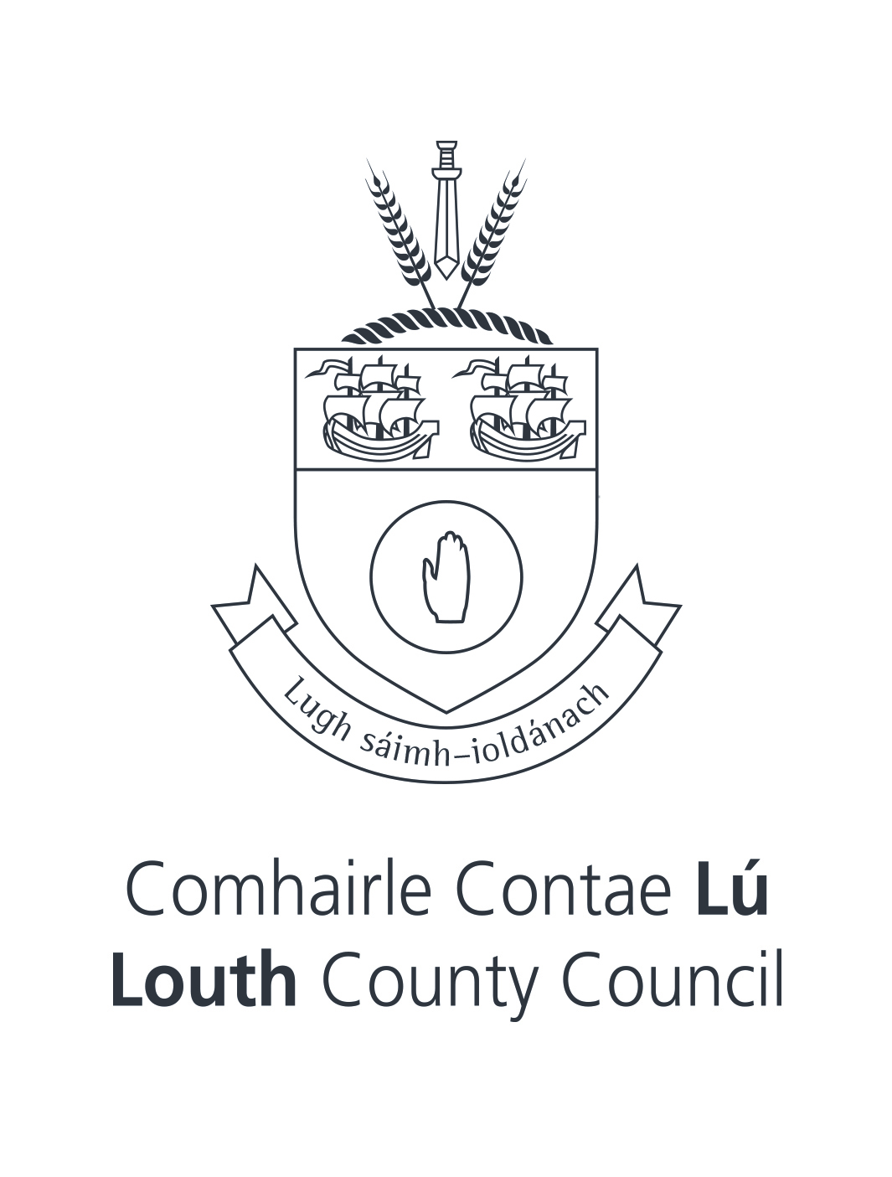
THE MUNICIPAL DISTRICT OF DUNDALK
PUBLIC NOTICE
The Municipal District of Dundalk Control of On-Street Bike Hire Bye-Laws 2023

The Members of the Municipal District of Dundalk in exercise of the powers vested in it by the provisions of Part 19 of the Local Government Act 2001 and all other enabling statutory powers and in the interest of enabling and regulating sustainable modes of travel in the common good of the local community have adopted Bye-Laws for the regulation of the operation of on-street bike hire and for the imposition of fixed payments for enforcement purposes, in respect of its administrative area in the Municipal District of Dundalk.

These Bye Laws will come into operation on the 19th of July, 2023.

A copy of The Municipal District of Dundalk Control of On-Street Bike Hire Bye-Laws 2023 are available for public inspection during normal office hours at The Offices of Louth County Council, County Hall, Millennium Centre, St. Alphonsus Road, Dundalk, County Louth A91 KFW6 and on the Louth County Council website at www.louthcoco.ie.
A copy of the Bye-Laws may be purchased on payment of the prescribed fee of €7.

William Walsh A/Director of Services
Placemaking & Physical Development Directorate
Louth County Council
County Hall
Dundalk
County Louth
20th June, 2023

