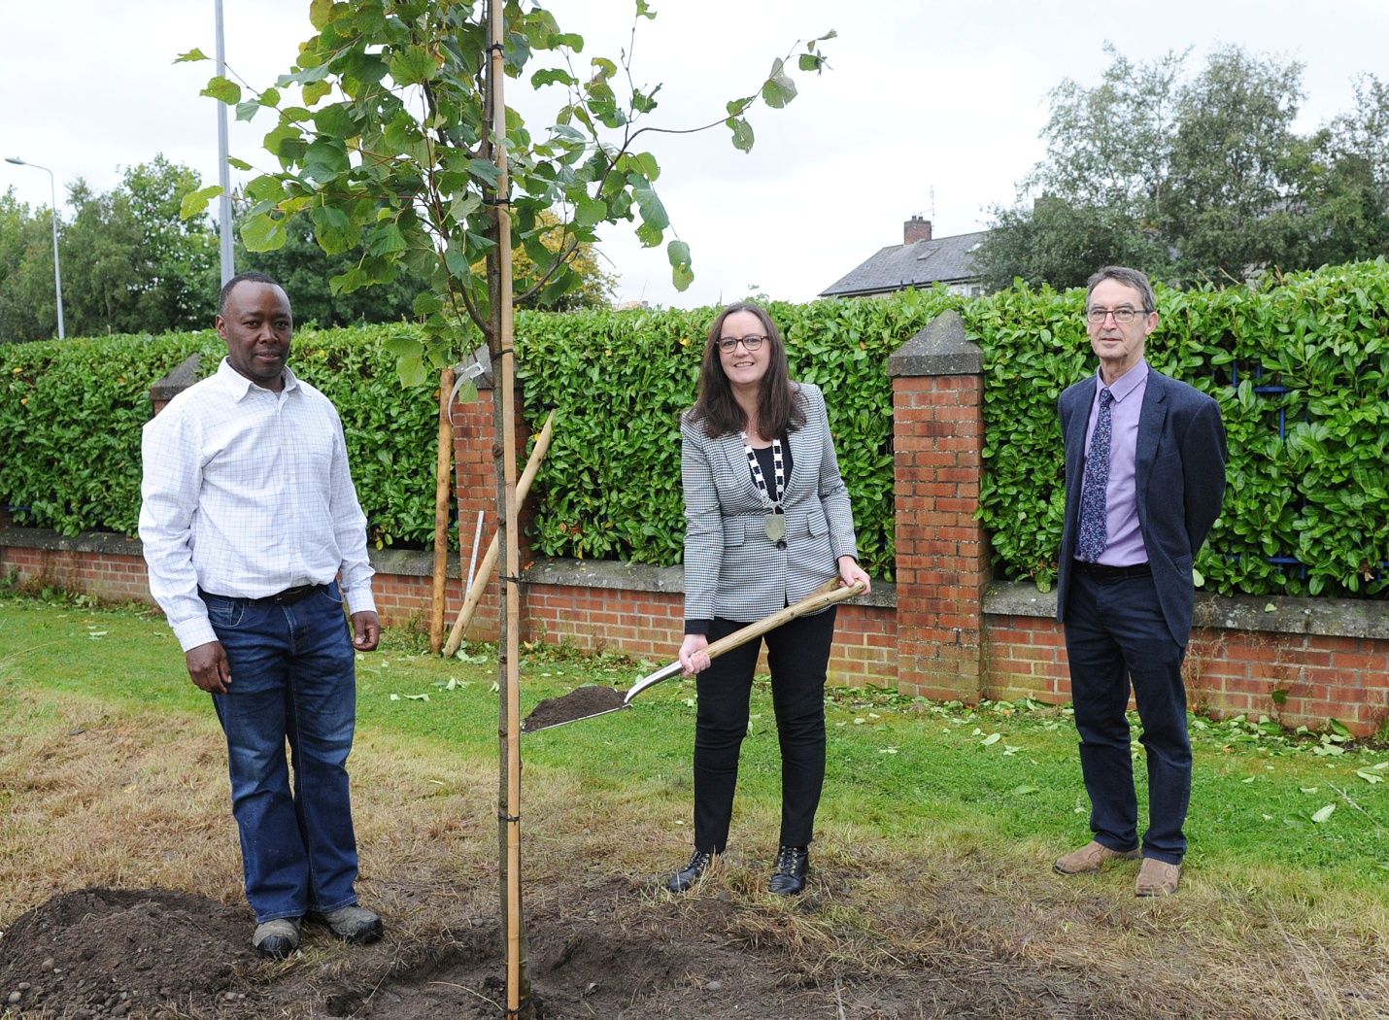
Tree planting at County Hall, Dundalk: Present are Elias Mlimbila Louth County Council Parks Department, Councillor Maria Doyle, Cathaoirleach of Dundalk Municipal District, and Willie Walsh Senior Executive Officer.

