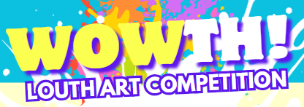
Application Form and Guidelines
Competition Entries must be returned in paper (2D) format (any size) using any media (e.g. mixed media, charcoal, paint, pencil, ink, textiles, crayons, pastels, colouring pencils, collage etc) to your local branch of Louth Library Services on or by Tuesday, 4th of June. Please attach this completed form with your entry.
There are 3 general categories: Under 7, 8-12 and 13-18 which are open to any theme. There is also a special theme category for all ages –Louth’s Brilliant Biodiversity. There will be an exhibition of submissions on Saturday, 15th of June in Dundalk Library, and the winners in each age category will be framed and displayed along with other entries. Prize winners will each receive a hamper of art/wildlife goodies. The winners of the special theme category may also have a chance to be featured in publications issued by Louth County Council’s Climate Team.
Please Select Category for Entry:
General Under 7 General 8-12 General 13-18
Special Theme Category (All Ages) Louth’s Brilliant Biodiversity
First Name _____________________ Surname __________________ Age _________
Title of Competition Entry ________________________________________________
Contact Number __________________ Email ________________________________
Home Address __________________________________________________________
__________________________________________________ Eircode _____________
By signing this form I understand that all entries together with the artists details (name, age, town of residency) may be used in publicity campaigns by Louth County Council and Creative Ireland. All entries shall be the property of Louth County Council and Louth County Council will not accept liability for loss or damage of work submitted.
Signature of parent/guardian ________________________Date _______________
