Louth County Council
Peters Street Public Realm Project
Appropriate Assessment Screening Report

28th April 2021

Contents Page No
Section 1 Introduction Page 3
1.1 Introduction Page 3
1.2 Appropriate Assessment Process (a) Page 4
1.3 Appropriate Assessment Process (b) Page 5

Section 2 Project Page 5
2.1 Site Description Page 5
2.2 Construction Materials Page 6
2.3 Restrictions on Working Hours Page 6
2.4 Timescale Page 6

Section 3 European Sites Page 6
3.1 Introduction Page 6
3.2 European sites within County Louth and County Meath Page 7
3.3 Conservation Objectives Page 7
3.4 Conservation Objectives for the European Sites within County Louth Page 8
3.5 Conservation Objectives for the European Sites within County Meath Page 10

Section 4 Screening Assessment Page 11

Section 5 Finding of no significant effects matrix Page 16

Conclusion and initial determination of screening report by Louth County Council Page 17

Section 1
Introduction:
This proposal is for the development of a public realm scheme at Peters Hill in Drogheda Town Centre. The scheme which provides for new paving, seating and public art will replace the existing car park at the location. The site is situated at the junction of Magdalene and Peter Street.

The project which has been named ‘Peters Hill meeting space’ has been allocated funding under PEACE IV / SEUPB
Map 1: below illustrates the location of the site in a local context.
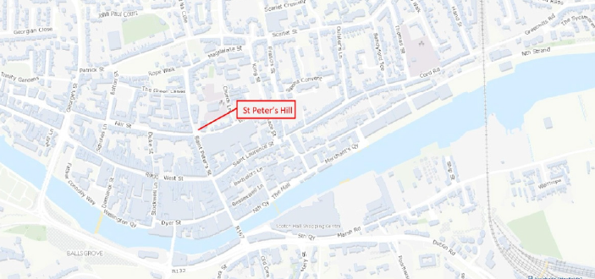
Map 2 .Site layout and proposed works:
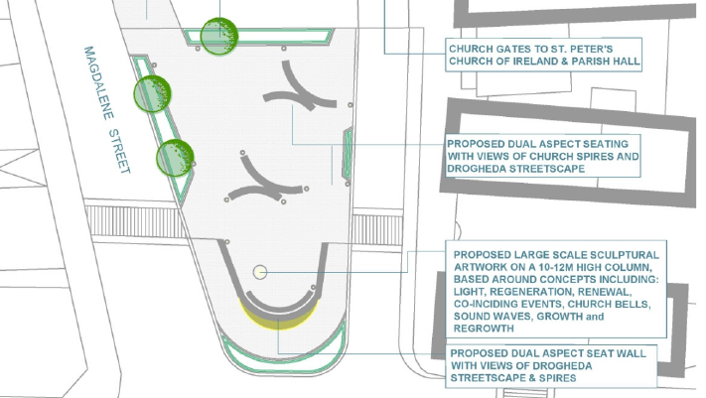

Photo image of Concept proposals for Peters Hill meeting space:
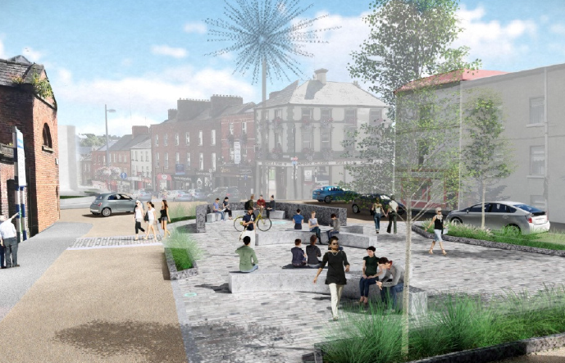
1.2 Appropriate Assessment Process (a)
The purpose of this Appropriate Assessment (AA) Screening process is to determine whether the proposed footpath, either alone or in combination with other plans or projects, could have significant effects on any European site, in view of that European site’s conservation objectives. This screening process determines whether appropriate assessment is necessary by examining:
- Whether a plan or project can be excluded from AA requirements because it is directly connected with or necessary to the management of the site, and

- The potential effects of a project or plan, either alone or in combination with other projects or plans, on a European site in view of its conservation objectives, and considering whether these effects will be significant.

1.3 The Appropriate Assessment Process (b)
Article 6 (3) and (4) of the Habitats Directive requires an assessment of a project or plan which may give rise to a significant effect on a European site. There are four stages included in the AA process which may be summarised below. This screening report is a first step assessment of the proposed project.
Stage 1: Screening
The first step to establishing if an appropriate assessment is required is referred to as ‘screening’ and its purpose is to determine on the basis of a preliminary assessment and objective criteria if the plan, alone or in combination with other plans or projects, could have a significant effect on a European site in view of the sites conservation objectives. The process identifies any likely impacts upon a European Site, either alone or in combination with other projects or plans, and considers whether these impacts are likely to be significant.
Stage 2: Appropriate Assessment
The consideration of the impact of the project or plan on the integrity of the European site, either alone or in combination with other projects or plans to the site’s structure and function and its conservation objectives. Additionally, where there are adverse impacts, an assessment of the potential mitigation of those impacts would be required.
Stage 3: Alternative Solutions
The process which examines alternative ways of achieving the objectives of the project or plan that avoid adverse impacts on the integrity of the European Site.
Stage 4: Imperative Reasons of Overriding Public Interest
This stage is the main derogation process of Article 6(4) which examines whether there are imperative reasons of overriding public interest (IROPI) for allowing a plan or project which will have adverse effects on the integrity of a European Site to proceed.
Section 2 – The Project
2.1. Site Description:
- The site is situated at the junction of Magdalene and Peter Street in the centre of Drogheda
- The area is characterised by retail outlets and public houses with several prominent Protected Structures in the vicinity.
- The site slopes down gently from the north to the road junction.
The main elements of the works are:
- removal of car parking spaces,
- redesign of the space as a pedestrian and meeting space, including high quality paving,
- retaining wall for the existing sloped surface to form an even pedestrian gradient,
- provision of high quality seating, soft areas for tree and groundcover planting,
- pedestrian crossings to adjoining streets and provision of a high level bespoke art work.

2.2 CONSTRUCTION MATERIALS: -
The following is a non-exhaustive list of materials that have been identified during construction and commissioning:-
- natural stone pavement and kerbs
- concrete used in forming the retaining wall
- Timber and granite seating
- Lighting
- Tree and shrub planting

2.3 Restrictions on Working Hours
Site development and building works shall be carried out only between the hours of 0800 to 1800 hours Mondays to Fridays inclusive, between 0800 to 1400 on Saturdays and not at all on Sundays and public holidays. Deviation from these times will only be allowed in exceptional circumstances where prior written approval has been received from the planning authority.

2.4 TIMESCALE FOR THE COMPLETION OF THE CONSTRUCTION WORK

It is intended that the project would be completed within a one-year timeframe or less.

Section 3 European Sites
3.1 Introduction
There are two types of EU designated sites in the locality; Special Areas of Conservation (SACs) and Special Protection Areas (SPAs). Special Areas of Conservation and Special Protection Areas are designated to afford protection to habitats and species listed in the Habitats and Birds Directives. The overall aim of the EC Habitats Directive is to maintain or restore the favourable conservation status of habitats and species of community interest. EU law requires Local Authorities to have regard to the integrity and conservation objectives of these sites when considering development proposals in their vicinity. The aim of the Birds Directive is to provide a framework for the conservation and management of wild birds in Europe and the maintenance of the populations of all wild bird species across their natural range.

3.2 European Sites within Co. Louth and County Meath
Table 1 provides a list of European sites within 15km of the site location. River Boyne and River Black Water SAC/SPA is approximately 300m away from the proposed project. Best Practice recommends that a distance of 15km is used as the likely zone of impact of a plan or project. Louth is surrounded by Co. Armagh, Co. Down, Co. Monaghan and Co. Meath all of which contain European sites. Those European sites which are located within a buffer of 15km are listed below. These have been considered in the context of the proposed works and it is not considered that the conservation objectives or the integrity of any of these sites would be affected.
Table 1: List of SACs and SPAs within 15 km radius of the site
Natura 2000 site | Site Code | Designation | Distance from Site
Clogherhead SAC | 001459 | Coastal/Estuarine | c. 12km north
Boyne Coast and Estuary SAC | 001957 | Coastal/Estuarine | c. 4.6km east
Boyne Estuary SPA | 004080 | Coastal/ Estuarine | c. 1.7km east
River Boyne and River Blackwater SAC | 002299 | Alkaline fens/River Habitat | c.0. 3km south
River Boyne and River Blackwater SPA | 004232 | Alkaline fens/ River Habitat | c. 0.3km south
River Nanny Estuary and Coast SPA | 004234 | Coastal/ Estuarine | c. 7.3km south-east

3.3 Conservation Objectives
The maintenance of habitats and species within European sites at favourable conservation condition will contribute to the overall maintenance of favourable conservation status of those habitats and species at a national level.
Favourable conservation status of a natural habitat is achieved when:
- its natural range, and area it covers within that range, are stable or increasing, and

- the specific structure and functions which are necessary for its long‐term maintenance exist and are likely to continue to exist for the foreseeable future, and

- the conservation status of its typical species is favourable.

The favourable conservation status of a species is achieved when:
- population dynamics data on the species concerned indicate that it is maintaining itself on a long‐term basis as a viable component of its natural habitats, and

- the natural range of the species is neither being reduced nor is likely to be reduced for the foreseeable future, and

- there is, and will probably continue to be, a sufficiently large habitat to maintain its populations on a long‐term basis.

3.4 Conservation Objectives for the European Sites within Co. Louth
Conservation Objectives for each of the European sites within County Louth have been detailed below from the best available data from the National Parks and Wildlife Service. This information is currently available by way of generic and specific conservation objectives, site synopsis (Appendix 1) and Natura 2000 data forms. As stated above the aim for all European sites is to either restore or maintain “favourable conservation status” of the habitats listed below.
Table 2: Conservation Objective for Boyne Coast and Estuary SAC (001957)
Conservation Objectives | Potential Impacts on SAC
Objective: To maintain the favourable conservation condition of the Annex I habitat(s) ] for which the SAC has been selected:  The Estuaries  Mudflats and sandflats not covered by seawater at low tide  Annual vegetation of drift lines [1210]  Salicornia and other annuals colonising mud and sand [1310]  Atlantic salt meadows (Glauco-Puccinellietalia maritimae) [1330]  Embryonic shifting dunes [2110]  Shifting dunes along the shoreline with Ammophila arenaria (white dunes) [2120]  Fixed coastal dunes with herbaceous vegetation (grey dunes) [2130] | - Water quality/pollution/ quantity  - Development / expansion of marinas and ports  - Dredging  - Disturbance to marine animals  - Dumping at sea  - Direct loss of habitat to development  - Recreational/amenity use  - Sea level rise  - Coastal defences

Table 3: Conservation Objectives for Clogherhead SAC 001459
Conservation Objectives | Potential Impacts on SAC
Objective:  1.To maintain the favourable conservation condition of Vegetated sea cliffs of the Atlantic and Baltic coasts in Clogherhead SAC  European dry heaths  1.To maintain the favourable conservation condition of European dry heaths in Clogherhead SAC, | - Recreational activities  - Climate change  - Nitrogen deposition  - General littering  - Animal grazing  - Burning

Table 4 Conservation Objectives for River Boyne and River Blackwater SPA 004232
Conservation Objectives | Potential Impacts on SAC
Objective:  1.To maintain or restore the favourable conservation condition of the bird species listed as Special Conservation Interests for this SPA:  - Kingfisher | - Water quality/pollution  - Direct loss of habitat to development  - Recreational/amenity use  - Loss of foraging/nesting grounds for birds  - Water and general pollution

Table 5 Conservation Objectives for Boyne Estuary SPA 004080
Conservation Objectives | Potential Impacts on SAC
Objective:  - To maintain the favourable conservation condition of:  - Shelduck  - Oystercatcher  - Golden Plover  - Grey Plover  - Lapwing  - Knot  - Sanderling  - Black-tailed  - Godwit  - Redshank  - Turnstone  - Little Tern  - Wetlands | - Water quality/pollution/ quantity  - Development / expansion of marinas and ports  - Dredging  - Disturbance  - Dumping at sea  - Direct loss of habitat to development  - Recreational/amenity use  - Sea level rise  - Coastal defences  - Direct loss of habitat to development  - Loss of foraging/nesting grounds for birds

Table 6 Conservation Objectives for River Boyne and Blackwater SPA 004232
Conservation Objectives | Potential Impacts on SAC
Objective: To maintain the favourable conservation condition of:  - Alkaline fens  - Alluvial forests  - River Lamprey  - Salmon  - Otter | - Water quality/pollution  - Direct loss of habitat to development  - Recreational/amenity use  - Water and general pollution  - Disturbance  - Animal grazing  - Burning

3.5. Conservation Objectives for the European Sites within Co Meath
Table 7 Conservation Objectives for River Nanny Estuary and Coast SPA 004234
Conservation Objectives | Potential Impacts on
Objective:  - To maintain the favourable conservation condition of:  - Oystercatcher  - Ringed Plover  - Golden Plover  - Knot  - Sanderling  - Herring Gull  - Wetland and Waterbirds | - Water quality/pollution  - Direct loss of habitat to development  - Recreational/amenity use  - Sea level rise  - Coastal defences  - Loss of foraging/nesting grounds for birds  - Water and general pollution

Section 4:
Screening Assessment
The following screening assessment integrates the information currently available on the European sites and the proposed works. The following template for this assessment is derived from the European Commission 2002 “Assessment of plans and [projects significantly affecting Natura 2000 site, Methodological guidance on the provisions of Article 6 (3) and (4) of the Habitats Directive 92/43/EEC”.

Describe the individual elements of the project (either alone or in combination with other plans or projects) with the potential to give rise to impacts on any of the European sites identified above.

River Boyne and River Black Water SAC/SPA is approximately 300m away from the proposed project. The designation of these European sites relates to the maintenance of the favourable conservation condition of the Annex I habitat(s) for which the SAC/SPA has been selected:

Objective: To maintain the favourable conservation condition of:
- Alkaline fens
- Alluvial forests
- River Lamprey
- Salmon
- Otter
- Kingfisher

The greatest threats to these European sites in the context of the conservation objectives are from water quality/pollution, development and expansion of marinas and ports, dredging, recreational and amenity use. The proposed project involves the development of a public realm scheme at Peters Hill in Drogheda Town centre. The scheme which provides for new paving, seating and public art will replace the existing car park at the location and does not encroach into the habitat area. This project does not propose to alter any of those habitats listed under qualifying interests.
Furthermore, there will be no alterations to the hydrological regime as a result of the proposed development. There will be no increase in surface water run-off as a result of the project and there will be no alterations to the existing surface water discharge points.
Describe any likely direct, indirect or secondary impacts of the project (either alone or in combination with other plan or projects) on the European site by virtue of:
Size and scale; | The proposed works are minor in scale and relate to the redesign of the space as a pedestrian and meeting space, including new paving, seating, soft areas for tree and groundcover planting and new pedestrian crossings to adjoining streets and provision of art work.
Land-take; | There are no proposals to encroach into or remove any of the habitats listed as qualifying interests of any of the European sites.
Distance from the European site or key features of the sites; | 300m south from the boundary of the SAC/SPA.  The distance from the other sites within 15kms is outlined in Table 1 of this report.
Resource requirements (water abstraction etc); | There are no resource requirements for the construction or operation of the development. The existing public roadways will be utilised for the construction traffic.
Emissions (disposal to land, water or air); | Existing surface water discharge points remain unaltered.
Excavation requirements; | Minor excavation on site relating to the removal of existing surface treatments and provision of new paving and services.  It is not proposed that there will be any excavation within the adjoining SAC/SPA. The proposed works at the site will not encroach onto the SAC/SPA.
Transportation requirements; | Transportation of materials will be required during construction which should be appropriately managed as part of waste management proposals, prior to transportation onto the site. Works will be controlled through a detailed site management system which shall ensure there is no impact on the habitats listed for Conservation Interest in the SAC/SPA.
Duration of construction, operation, decommissioning, etc; | The duration of the construction period will be short approximately 12 months from commencement.
Other | No other impacts are envisaged during construction or operation.

Describe any likely changes to the European site arising as a result of:
Reduction of habitat area; | There will be no reduction in the habitat areas listed as qualifying interests for any of the European Sites
Disturbance to key species, | There will be no disturbance to key species within any of the European Sites, in particular River Boyne and Black Water SAC/SPA during construction or operation of the works. This is due to the scale and nature of the proposed works.  A desktop survey was undertaken with regard to the possible disturbance to protected species by analysis of the details of the site synopsis and information contained on both the NPWS and National Biodiversity Centre website. It was concluded that there should be no disturbance to any species protected within any of the European Sites
Habitat or species fragmentation, | There will be no changes to the habitats of any of the European Sites
Reduction in species density; | There will be no reduction in species density from the proposed development. The employment of best construction methods shall ensure that the existing habitats and species are protected in their natural state and that the proposed works should have no negative impact on the adjoining SAC/SPA or any other European site
Changes in key indicators of conservation value (water quality); | There are no proposed changes to key indicators of conservation value due to the construction of this site.
Climate change | It is not envisaged that these activities or the construction works would lead to an increase in climate change.

Describe any likely impacts on the European site as a whole in terms of:
- Interference with the key relationship that define the structure of the site,
- Interference with key relationship that defines the function of the site,
Provide indicators of significance as a result of the identification of effects set out above in terms of:
Loss, | There is to be no habitat loss as a result of these proposed works and therefore no significant impact.
Fragmentation; | The project does not propose to cause any fragmentation to any of the identified European Sites by way of construction or operation.
Disruption & Disturbance; | There is no significance placed on the disruption of any of the conservation objectives of the SAC/SPA or disturbance of any of the species within the SAC/SPA as there is no proposed land take or any features of the proposed construction or operation which should impact on the water quality. Best practice construction works will be employed.
Change to key elements of the site (e.g. water quality etc) | There are no identified elements of the project which should cause any significant impact on the water quality or integrity of the European sites within 15km of the proposed route.  C construction or operation of the site will not impact on the water quality. Additionally site management during construction will take cognisance of the adjoining European sites as follows:

Describe from the above those elements of the project or plan, or combination of elements, where the above impacts are likely to be significant or where the scale or magnitude of impacts is not known;
From the information contained above it is evident that the proposed development is not likely to cause any significant adverse effects on the integrity of the Conservation Objectives of the identified European sites. The construction or operation is not likely to have adverse effect on the European conservation objectives of the identified sites. Best practice construction measures will be employed and are classified as intrinsic measures to the overall project so as not to cause any environmental damage on any surrounding areas. The qualifying interests of the River Boyne and River Blackwater SAC/SPA and the other European Sites identified within 15kms of the site of the proposed works would not be affected due to the location of the project site relative to these sites and intervening terrain/topography, the nature and scale of the project works. Further, construction runoff will be controlled by site management and will not impact on the water quality or species listed within the SAC/SPA.

Section 5:
- Finding of No Significant Effects matrix (FONSE) and conclusion of determination.
Following the assessment in section 4.0 of the proposed works and regarding the conservation objectives of the European sites in accordance with the ‘Methodological guidance on the provision of Article 6(3) and (4) of the Habitats Directive 92/43’, a Screening Matrix and Findings of No Significant Effects Matrix have been completed and included below.
Table 4: Finding of no significant effects matrix (FONSE)
Name of Project | Peters Street Public Realm Project.
Name and location of Natura 2000 site | The site is located 300m away from River Boyne and River Blackwater SAC/SPA. The conservation objectives of the SAC/SPA are set out in this report along with the conservation objectives pertaining to all European sites located within 15kms of the project site
Description of the project | Louth County Council is proposing works which will involve the redesign of the space as a pedestrian and meeting space, including new paving, seating, soft areas for tree and groundcover planting and new pedestrian crossings to adjoining streets and provision of art work.
Is the project directly connected with or necessary to the management of the site (provide details)? | No, the project is not connected to the management of the SAC/SPA.
Are there other projects that together with the project or plan being assessed could affect the site (provide details)? | To the knowledge of the Local Authority there are no additional proposed works directly connected with this site.
The Assessment of Significance of Effects

Describe how the project or plan (alone or in combination) is likely to affect the European site | The proposed works do not give rise to any direct impacts on the habitats for which the above identified European Sites are protected for in particular River Boyne and River Blackwater SAC/SPA. This is due to the characteristics and location of the site (within an existing urban streetscape) and nature and scale of works.  The employment of a construction plan will ensure that any possible indirect effects from the site works on the European sites will be negligible and do not give rise to any reasonable scientific doubt regarding potential adverse effects. Construction works are confined to the existing car parking area
Explain why these effects are not considered significant | The indirect effects are not considered to be significant as they would not cause any likely significant adverse effects on the qualifying interests of any of the European site by way of habitat loss or changes to hydrological regimes pertaining to any of the designated sites
Data collected to carry out the assessment

Who carried out the assessment | Louth County Council.
Sources of data | Field Assessment (Louth County Council).  Design and Construction details (Engineering Louth County Council)  National Parks and Wildlife Survey (Natura 2000, Site Synopsis, Conservation Objectives and EU data forms).
Level of assessment | Screening for Appropriate Assessment: (In addition to field assessment an extensive desktop survey was used to assess the significance of the proposed works on the European sites).
Where can the full results of the assessment be accessed and viewed? | This screening report will be made available to the public on request

Conclusions and determination of screening report by Louth County Council.
It is reasonable to conclude that the proposed development, individually or in combination with other plans or projects would not be likely to have a significant effect on River Boyne and River Blackwater SAC/SPA or any other European Sites, in view of the sites’ Conservation Objectives and a Stage 2 AA and a Natura Impact Statement is not therefore required.

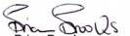
Brian Brooks
Executive Planner
Date: 10/05/21

Appropriate Assessment of Plans and Projects in Ireland- Guidance for Planning Authorities, Department of Environment, Heritage and Local Government 2009 (revised 2010).
Council Directive 92/43/EEC on the conservation of natural habitats and of wild fauna and flora
Appropriate Assessment of Plan and Projects in Ireland, Guidance for Planning Authorities. DoEHLG, 2010.
NPWS (2011) Conservation objectives for Dundalk Bay SAC (000455) Generic Version 4.0. Conservation objectives for Dundalk Bay SPA (004026) Generic Version 3.0. Department of Arts, Heritage & the Gaeltacht.
Section of screening form derived from Annex 2 of the document Assessment of plans and projects significant affecting Natura 2000 sites- Methodological guidance on the provisions of Article 6(3) and (4) of the Habitats Directive 92/43/EEC, developed by Oxford Brookes University on behalf of DG Environment and published by the European Commission in 2002.

