Part 8 Planning Statement, Peters Hill Drogheda New Meeting Space

Contents

- Introduction

- Site context

- Proposed Development

- Planning Policy context

4.1 Protected Structures

- Parking

5.1 Provision of Bicycle Parking

- Construction Management Method Statement

- Part 8 Planning Documents List

PART 8 – PLANNING STATEMENT PETERS HILL, DROGHEDA MEETING SPACE

- Introduction

Louth County Council intends to carry out the development of a new Meeting Space at Peters Hill, in Drogheda, County Louth.

This project is supported by the European Union’s PEACE IV Programme, managed by the Special EU Programmes Body (SEUPB). Match-funding has been provided by the Executive Office in Northern Ireland and the Department of Rural and Community Development in Ireland.

- Proposed Development

The proposed Meeting Space will include provision of high quality paving and seating, removal of existing public car parking and reallocation of existing Blue Badge or wheelchair accessible parking to adjoining streets, construction of a retaining structure to modify the existing gradient, provision of areas of soft planting and street tree planting, provision of a bespoke sculptural art work (to later detail).

- Site Context

Peter’s Hill is located within Drogheda’s Heritage Quarter. The site is located on elevated ground that provides long views to the south towards the Tholsel and Millmount in Drogheda. Peters Hill is an open space located at the top of St Peter’s Street at the junction with Magdalene Street, William Street and Fair Street. The site is currently in use as a Public Parking area.

The site area at Peters Hill is defined to the north and west by two and three storey buildings of mixed residential and business uses. The north east corner is defined by cut stone plinths and decorative wrought iron gates that form the entrance to St Peter’s Church of Ireland. The eastern extent of the proposed site is defined by St. Johns Homes that are located within the curtilage of St Peter’s Church of Ireland. The southern site extent is defined by the junction of St Peters Street, William Street and Fair Street with Clarkes Bar, The Carnegie Library Boomerang Youth Cafe and The Barbican Centre, Drogheda are all located in close proximity.

- Planning Policy context

The proposed works are within Drogheda Architectural Conservation Area No 11; Saint Peter’s Church and its Environs as designated in the Drogheda Borough Council Development Plan 2011-2017.
The works are within a zone of archaeological potential.

Peters Hill is specifically mentioned under various sections of The Urban Design Framework Plan Drogheda Heritage Quarter:

In Section of 7.0 Towards Implementation of The Urban Design Framework Plan Drogheda Heritage Quarter:
Early Win Projects - identify and prioritise, e.g., Peter’s Hill, St. John’s housing.

Also in The Urban Design Framework Plan Drogheda Heritage Quarter Peters Hill is noted in the urban spatial sequences of Drogheda highlighted
‘four urban spatial sequences of Drogheda which can be considered of national importance. Their value lies in the quality of spatial enclosure and the integrity and coherence of the space.
‘6.42 Peter’s Hill: important civic space within principal urban sequence’

In Map 5.11 Peters Hill is demarcated as a ‘Intervention – recovery- Opportunity – HOTSPOT’
‘there are areas (some of these are identified here as ‘repair hot-spots), where focused development is required. This ranges from bringing important buildings back into use (e.g. the St. John’s housing at Peter’s Hill) to public realm improvements (e.g., Peter’s Hill, Potato Market, The Mall).’

A sketch schematic plan in The Urban Design Framework Plan Drogheda Heritage Quarter shows removal of parking and redesign of the public space at Peters Hill under
6.6.1 Principal Recommendations arising from analysis of Urban (Paved) Spaces
17. Peter’s Hill Square
Ambience: Improve heritage setting; views and information.Microclimate potential
Activity: Improve street furniture, seating and social uses
Movement: Improve pedestrian and cycle mobility, provide vehicular drop off and cycle racks Traffic calm, and reduce impact of parking (create multi uses)
Nature: Improve biodiversity

  - Planning Policy context – Protected Structures
The National Inventory of Architectural Heritage (NIAH) shows a number of protected structures are located in proximity and fronting onto the space at Peters Hill. The site however is not within curtilage of these protected structures.

The proposals for Peters Hill will support the analysis of The Urban Design Framework Plan Drogheda Heritage Quarter by improving the setting of these protected structures.

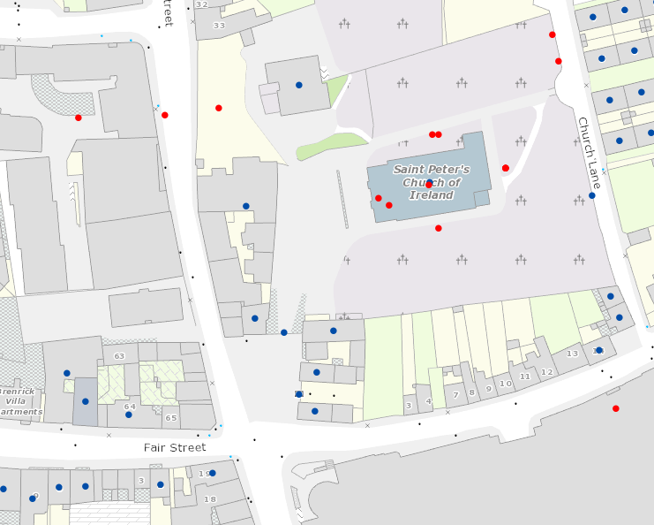
https://maps.archaeology.ie/historicenvironment/

The new meeting space at Peters Hill will be formed using high quality, durable materials, including natural stone paving and kerbing. Public lighting and information etc will be located within the space to provide ease of access and movement for all and safeguard the setting and views of protected structures.
The access road leading to St Peters Church of Ireland Gates will be demarcated (within the shared surface area) by a change in the (appropriate) material or colour.

Removal of car parking and redesign of the space will allow an open area and vista for the protected structures that front onto Peters Hill meeting space.

- Parking
There is currently town centre parking available in the vicinity of Peters Hill (excluding Peters Hill Public Parking area) in the adjoining streets:
- Fair Street (40 spaces)
- Private car park in The Laurence Shopping Centre (387 spaces)
With on-street parking also available at
- William Street,
- Magdalene street
- St Peter Street

The current number of parking spaces at Peters Hill Public Parking area is 9 spaces, including 1 Blue Badge or Wheelchair Accessible space. There are currently 71 blue Badge or Wheelcair accessible car parking spaces in Drogheda town centre streets.

Prior to development of the Meeting Space at Peters Hill the Blue Badge or Wheelchair Accessible car parking space will be relocated in the adjoining streets to Peters Hill at the closest possible location.
The remaining 8 parking spaces at Peters Hill Public Parking area will be accessible in the capacity of adjoining streets.

  - Provision of Bicycle Parking
The proposals for the Meeting Space at Peters Hill will include bicycle parking to promote alternative means of transport and reducing carbon within town centre spaces.

- Construction Management Method Statement
The successful contractor will be required to submit detailed construction management plan and method statement containing site specific measures to ensure avoidance of pollution or disturbance related impacts during the construction stage prior to LCC prior to commencement of development.

- Part 8 Planning Documents list

Drawing title: Peters Hill Drogheda Existing & Proposed Site Layout

Drawing title: Peters Hill Drogheda Existing & Proposed Sections

Appropriate Assessment Screening Report

Road Safety Audit – Stage One report

Planning Statement

