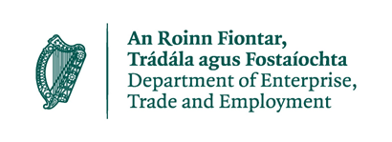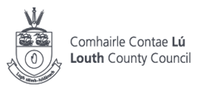

As part of Budget 2024, the Government signed off on a package of €257m for the Increased Cost of Business (ICOB) Grant as a vital measure for small and medium businesses. Louth County Council, funded through Department of Enterprise, Trade and Employment (DETE), will manage the rollout of the grant to qualifying businesses.
Eligible businesses will receive a once-off grant payment. The amount of the grant payable to eligible businesses is based on the value of the Commercial Rates bill the business received in 2023. However, it is not a Commercial Rates waiver and businesses should continue to pay their Commercial Rates bill as normal.
What is the purpose of the grant?
The grant is available to qualifying businesses as a contribution towards the rising costs faced by businesses. The grant is intended to aid businesses but is not intended to directly compensate for all increases in wages, or other costs, for every business.
How much is the grant?
The grant is based on the value of the Commercial Rates bill received by an eligible business in 2023.
- For qualifying businesses with a 2023 Commercial Rate bill of <€10,000, the ICOB grant will be paid at a rate of 50% of the business’s Commercial Rate bill for 2023.
- For qualifying businesses with a 2023 Commercial Rate bill of between €10,000 and €30,000, the ICOB grant will be €5,000.
- Businesses with a 2023 Commercial Rates bill greater than €30,000 are not eligible to receive an ICOB grant.
What businesses are eligible to receive the grant?
The following are the main qualifying criteria:
- Your business must be a commercially trading business currently operating from a property that is commercially rateable.
- Your business must have been trading on 1st February 2024 and you must intend to continue trading for at least three months from the date you verify your information.
- You must provide confirmation of your bank details.
- Your business must be rates compliant. Businesses in performing payment plans may be deemed to be compliant.
- Your business must be tax compliant and must possess a valid Tax Registration Number (TRN).
Please note that Louth County Council reserves the right to claw back any grant payment which is later found to be incorrect. This includes any circumstances such as error by the recipient business or the local authority making the payment, or where a business makes a false declaration of eligibility.
How soon can businesses avail of the grant?
An online system is being developed to manage the submission of essential information. Louth County Council will write shortly to businesses with further details, including how to register and how to submit information online. The system is expected to be available in mid-March.
What is the closing date?
The closing date for businesses to confirm eligibility and to upload verification details will be 1st May 2024.
Where can I find out further information?
Further correspondence and guidance will be issued to commercially rateable businesses in the next few weeks. In addition, an FAQ will be available online when the grant scheme opens. You should refer to this guidance and FAQ prior to making your submission.
If you have queries regarding your Commercial Rates account including outstanding balances, contact Louth County Council at 042 9335457 or email ICOBGrant@louthcoco.ie. Our team are happy to discuss any balances outstanding on your rates and what steps can be taken to ensure compliance with the scheme.
