USE OF NEW RAISED PEDESTRIAN “COURTESY CROSSINGS” IN DROGHEDA

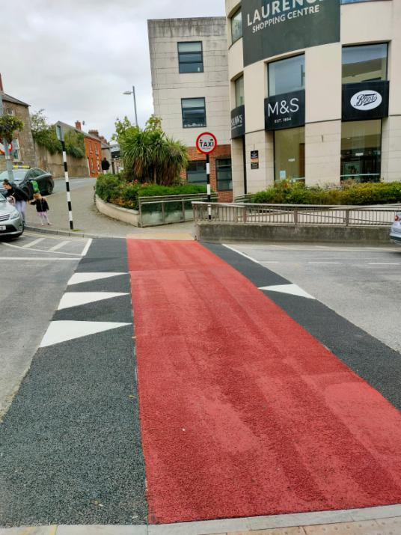
PETERS STREET DROGHEDA

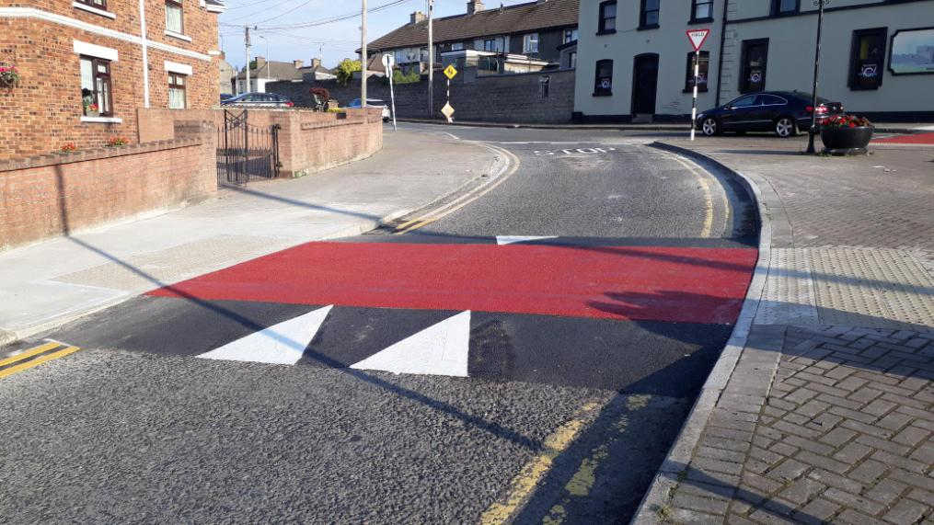
HARDMAN’S GARDENS DROGHEDA

The new pedestrian ramps in Drogheda are “Courtesy Crossings” and the Rules of the road apply as per page 201 of the Road Safety Authority Rules of the Road below

https://www.rsa.ie/services/learner-drivers/resources/rules-of-the-road

