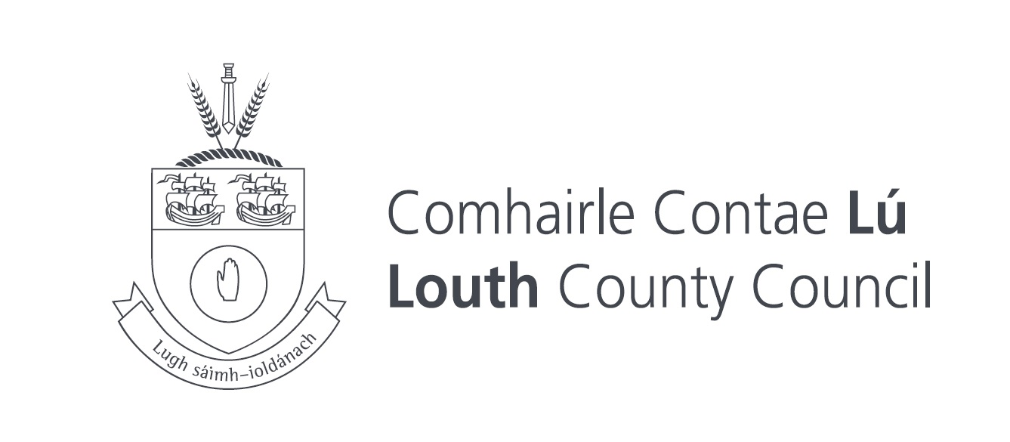
Uaireanta Oscailte agus Dúnta
Opening and Closing hours
Samhain, Nollaig & Eanáir 10.00r.n. – 5.00i.n.
November , December & January 10.00am- 5.00pm.
Feabhra & Márta 10.00r.n. – 6.00i.n.
February & March 10.00am – 6.00pm.
Aibreán & Deireadh Fómhair 10.00r.n. – 7.00i.n.
April & October 10.00am – 7.00pm .
Bealtaine, Lúnasa & Meán Fómhair10.00r.n. – 9.00i.n.
May, August & September 10.00am – 9.00pm.
Meitheamh & Iúil 10.00r.n. – 10.00i.n.
June & July 10.00am -10.00pm .
Dúnfar an pháirc seo amanna le haghaidh obair chothabhála riachtanach.
This park may be closed at any time for essential maintenance work .

Sonraí Teagmhála / Contact Details
Comhairle Contae Lú/Louth County Council (042) 933 5457
Oispidéal Chontae Lú / Louth Hospital (042) 933 4701
An Garda Síochána (042) 938 8400
Éigeandáil / Emergency 112 or 999

