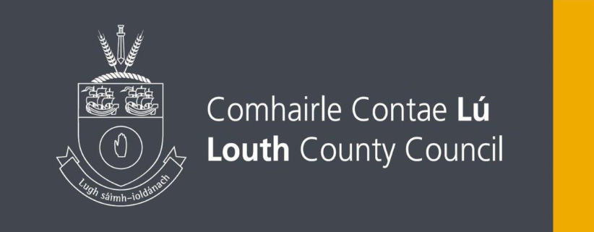
THE MUNICIPAL DISTRICT OF ARDEE
PUBLIC NOTICE
The Municipal District of Ardee (Casual Trading Act 1995) Bye-Laws 2024

The Members of the Municipal District of Ardee, within the administrative area of Louth County Council, in exercise of the powers conferred upon Louth County Council by Section 6 of the Casual Trading Act 1995 and upon them by Section 131A of the Local Government Act 2001, have adopted Bye-laws for the control, regulation, supervision and administration of casual trading in the Ardee Municipal District, within the functional area of Louth County Council.
These Bye Laws came into operation on the 01st February 2024.

A copy of The Municipal District of Ardee (Casual Trading Act 1995) Bye-Laws 2024 are available for public inspection during normal office hours at The Offices of Louth County Council, County Hall, Millennium Centre, St. Alphonsus Road, Dundalk, Co. Louth A91 KFW6 and on the Louth County Council website at www.louthcoco.ie.
A copy of the Bye-Laws may be purchased on payment of the prescribed fee of €7.

Willie Walsh
Senior Executive Officer
Placemaking & Physical Development
Louth County Council
Millennium Centre
Dundalk
Co. Louth
02nd April 2024.

